**Django-Notes-Application-Project_1**

Step-1

Setting up Jenkins

Launch an ec2 instance with port 22 & 8080 enabled , and connect to ec2 through ssh .

After that install java in it , also install Jenkins ,enable and start the service .

<https://www.jenkins.io/doc/book/installing/linux/#red-hat-centos>

sudo wget -O /etc/yum.repos.d/jenkins.repo \

https://pkg.jenkins.io/redhat-stable/jenkins.repo

sudo rpm --import https://pkg.jenkins.io/redhat-stable/jenkins.io-2023.key

sudo yum upgrade

*# Add required dependencies for the jenkins package*

sudo yum install fontconfig java-17-openjdk

sudo yum install jenkins

You can enable the Jenkins service to start at boot with the command:

sudo systemctl enable jenkins

You can start the Jenkins service with the command:

sudo systemctl start jenkins

You can check the status of the Jenkins service using the command:

sudo systemctl status jenkins

and browse the ip with the port 8080 and you will see the Jenkins service started .

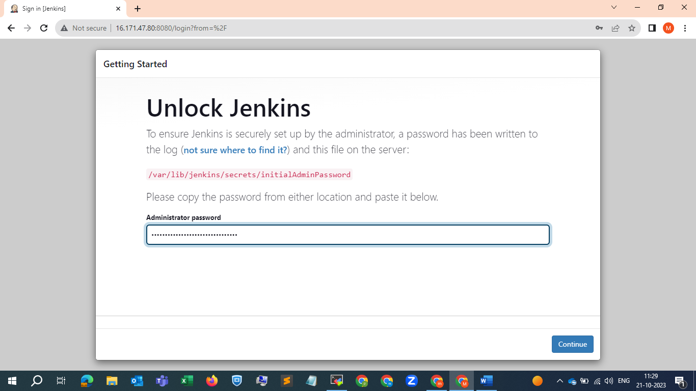

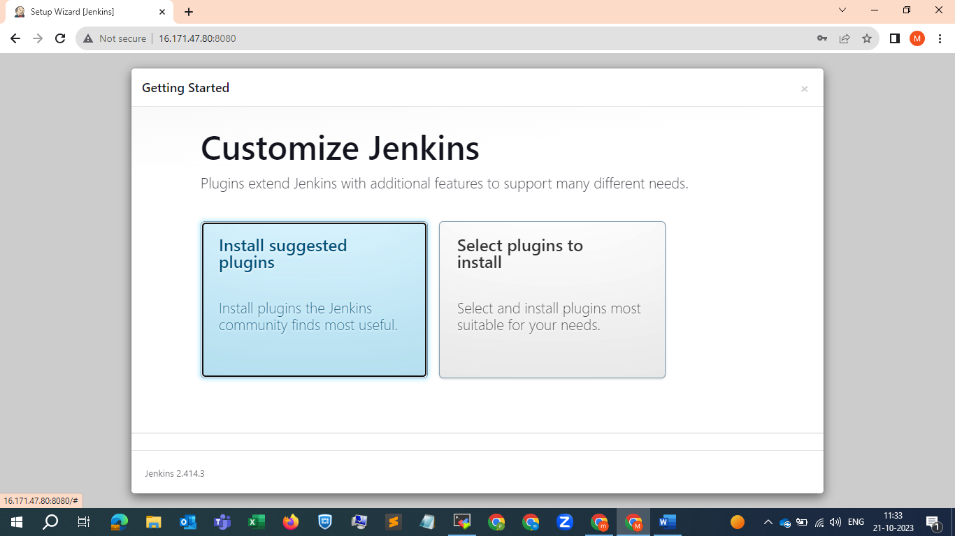

Select the install suggested plugins

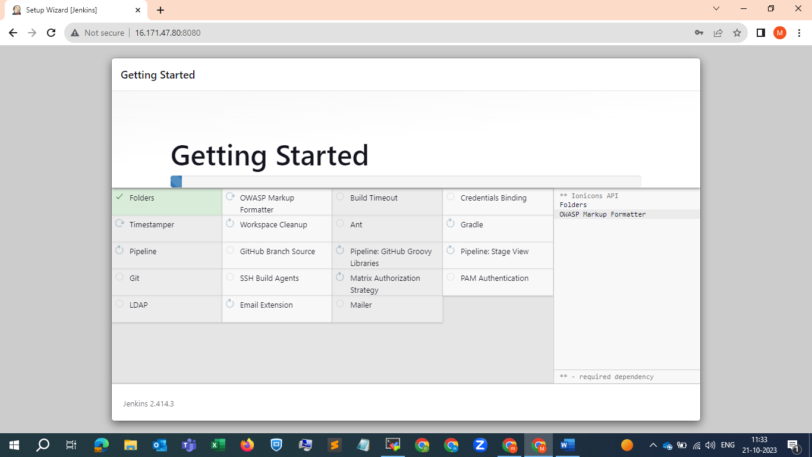

Then it will ask for creating user you can create the user or just click skip and continue as admin

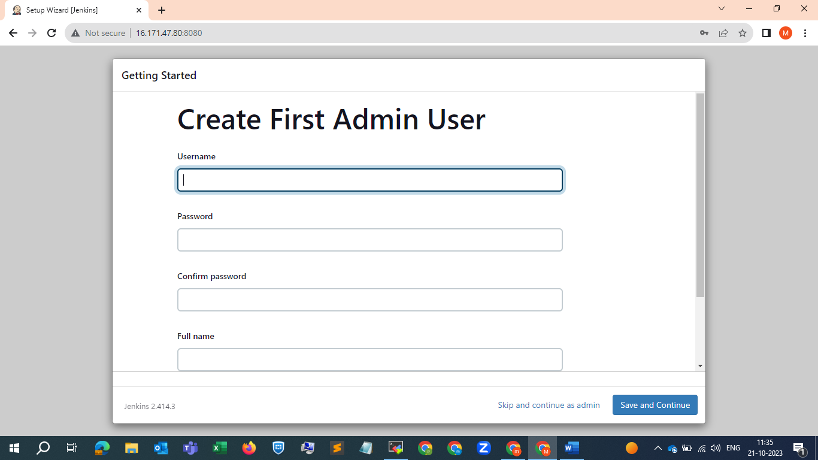

After that save and finish

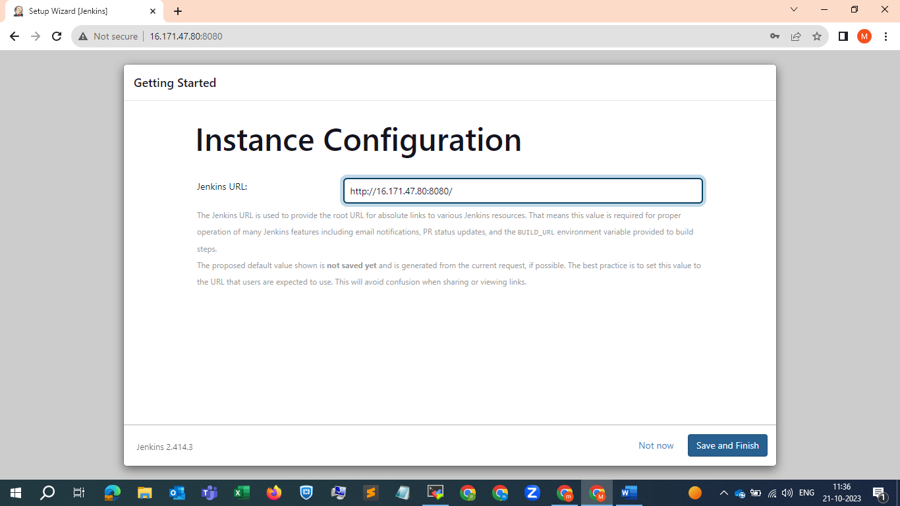

And start using Jenkins

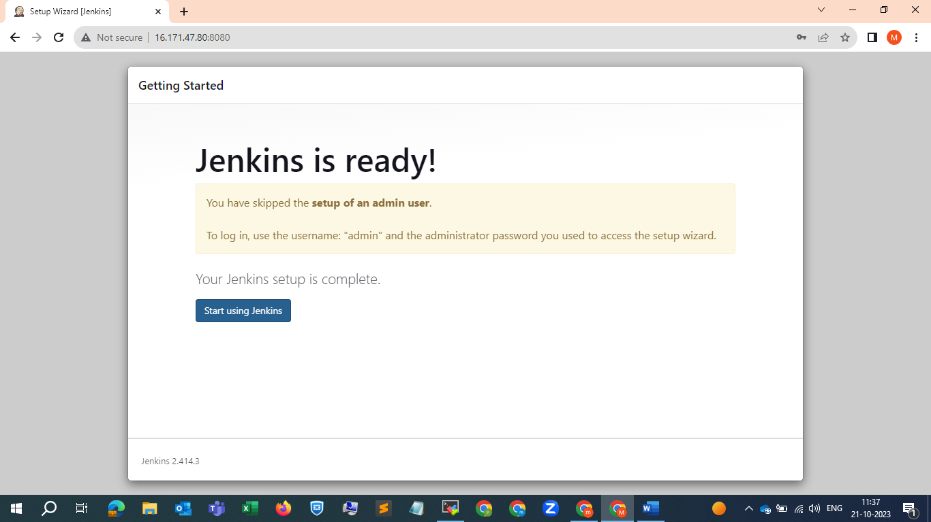

And we redirected to Jenkins dashboard page

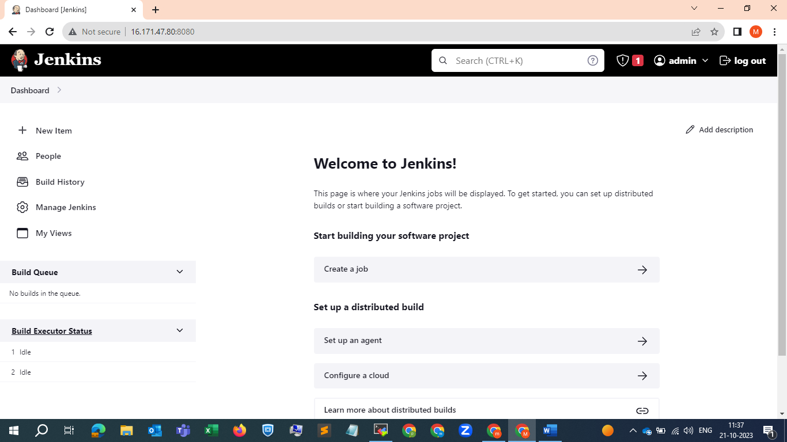

Step-2

Click on new item , and give the name of the job and select pipeline and click on ok as shown in below SS

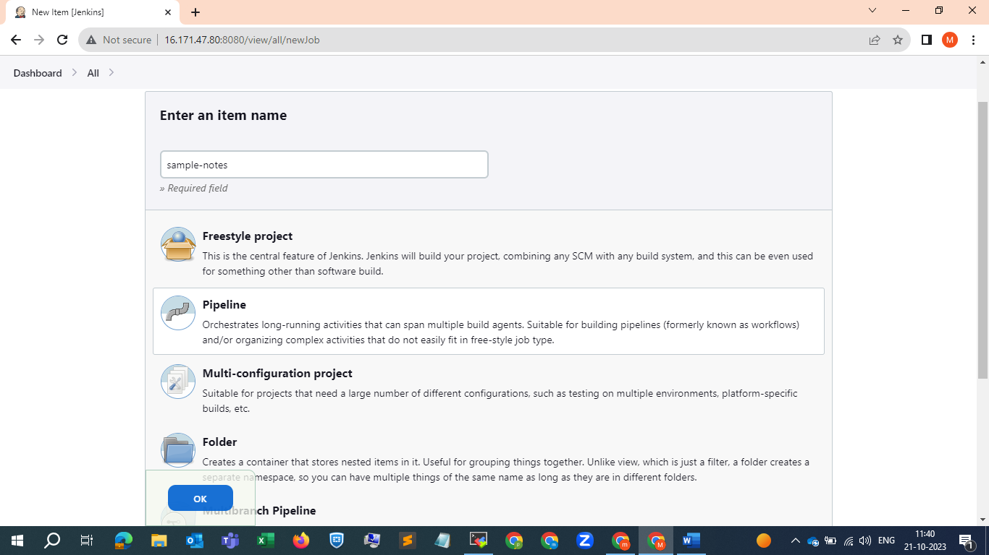

Give description and select max build to keep 2 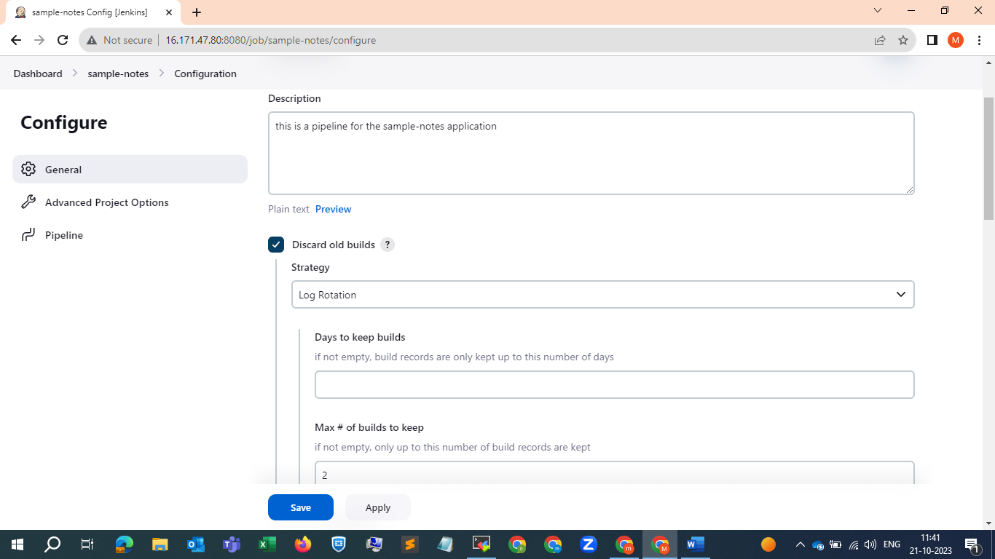

Next go to pipeline and start writing script , just select any sample pipeline in the right and after that under stages just copy stage section under braces and copy it and paste it few more times accordingly depending on number of tasks or jobs that we are performing .

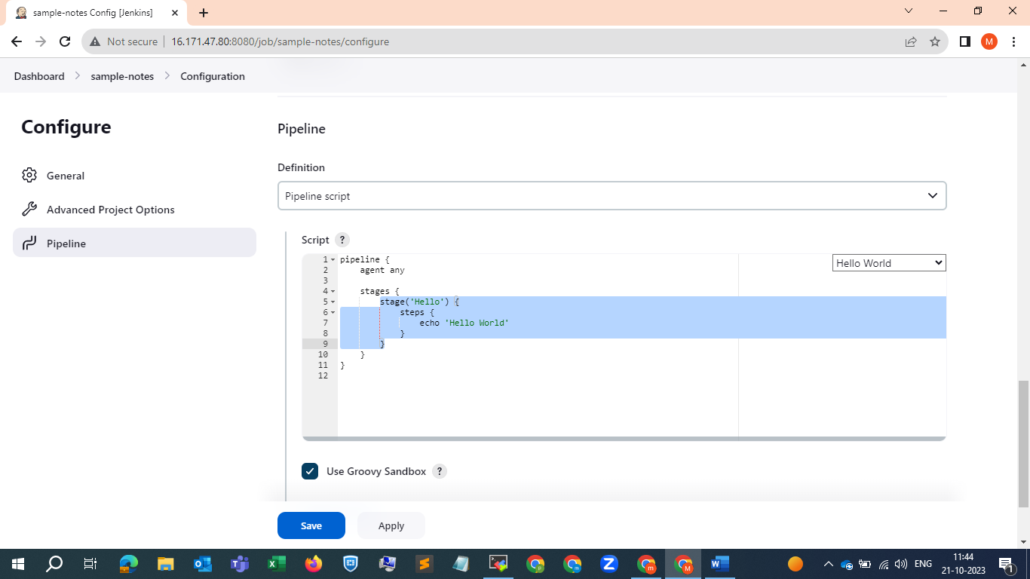

As we are performing 4 stages we copied it four times .

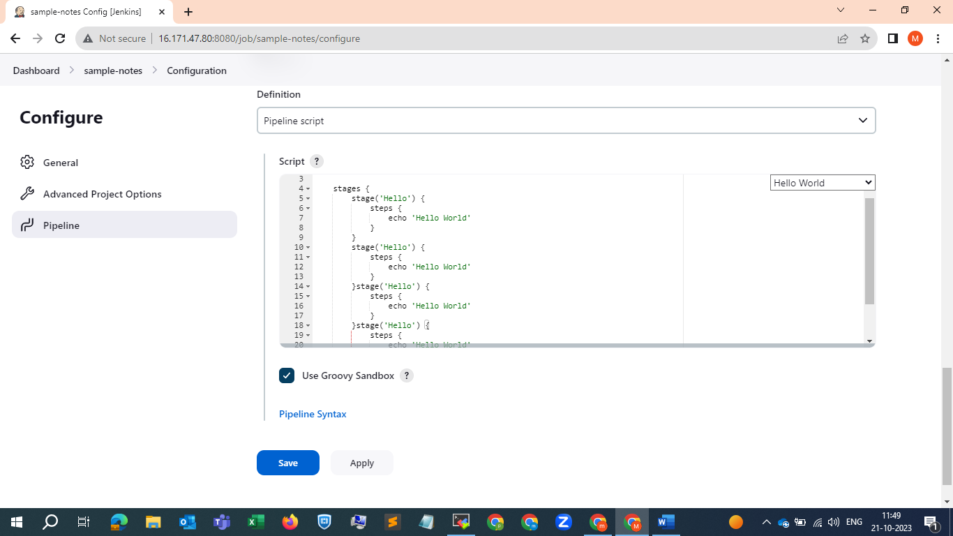

And give names to stages like 1st one I have given Git checkout and click on pipeline syntax for the git pipeline script.

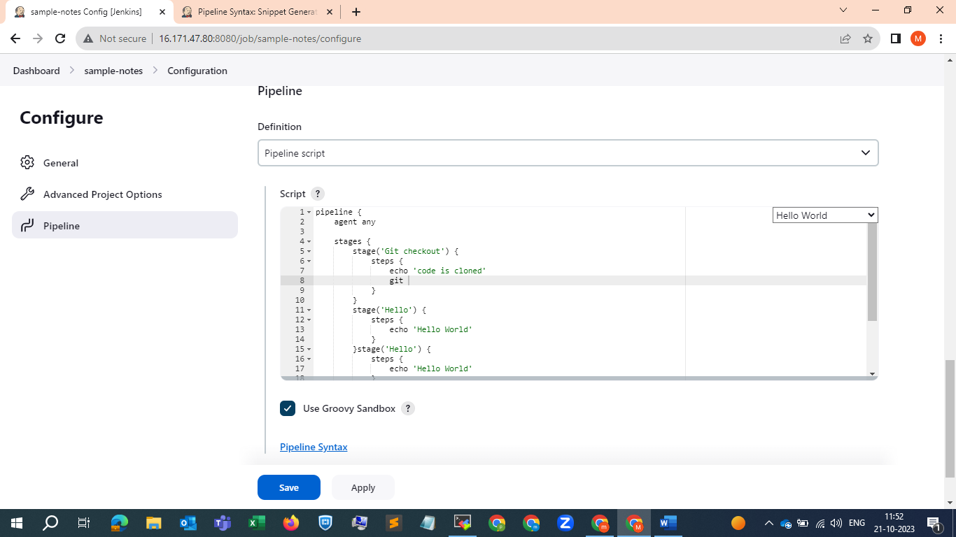

As I already have the code , we just copy the repository link and paste it in pipeline-syntax to generate a pipeline script

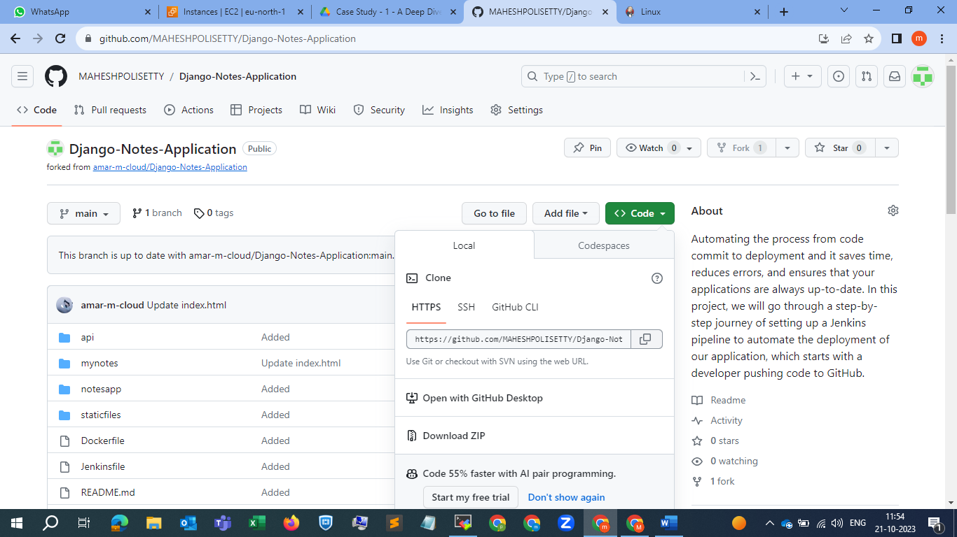

And make sure branch name is correct and click on generate pipeline script.

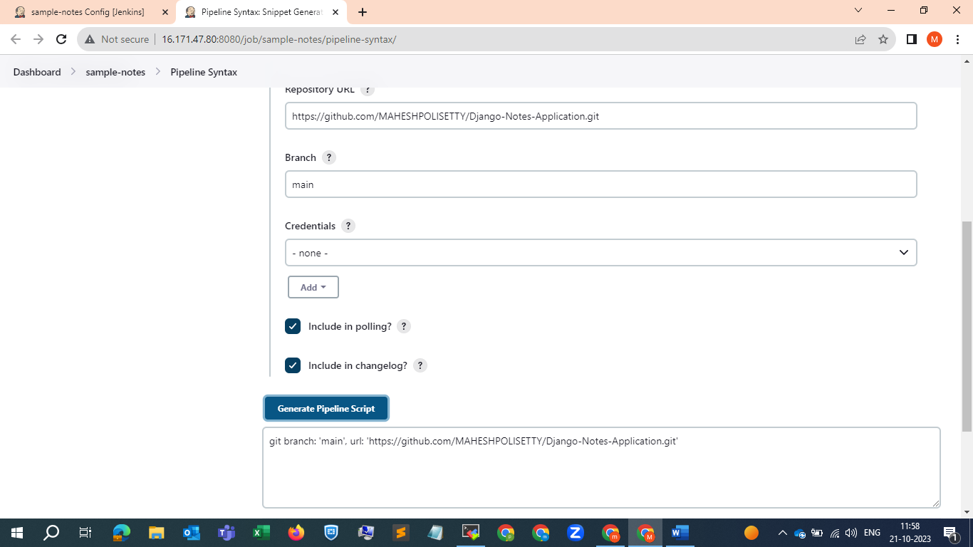

Here we go , I have updated al the changes in the script , I m just saving it not building it now as , I have not configured the docker credentials yet , once I updated them and configuring other services that are required , I will build it . just updated the script for now . 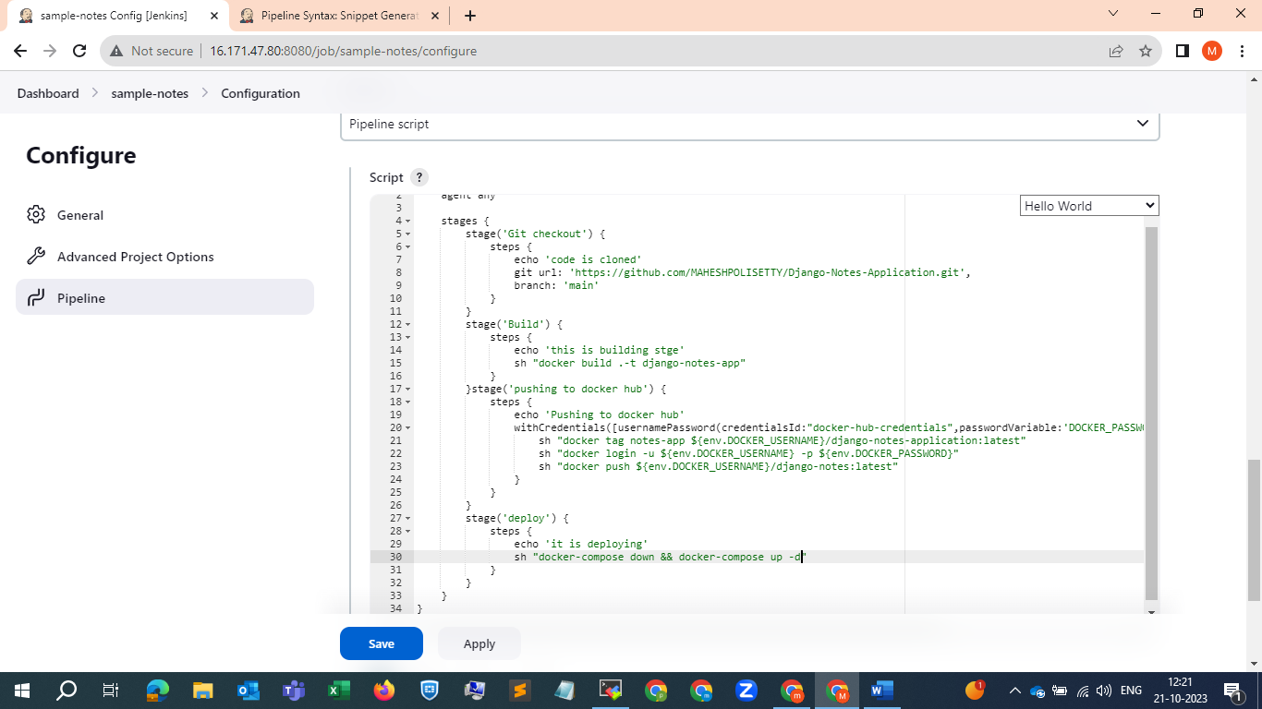

Once it is saved now go to manage Jenkins section 🡪 plugins🡪 install these docker plugins and configure accordingly . 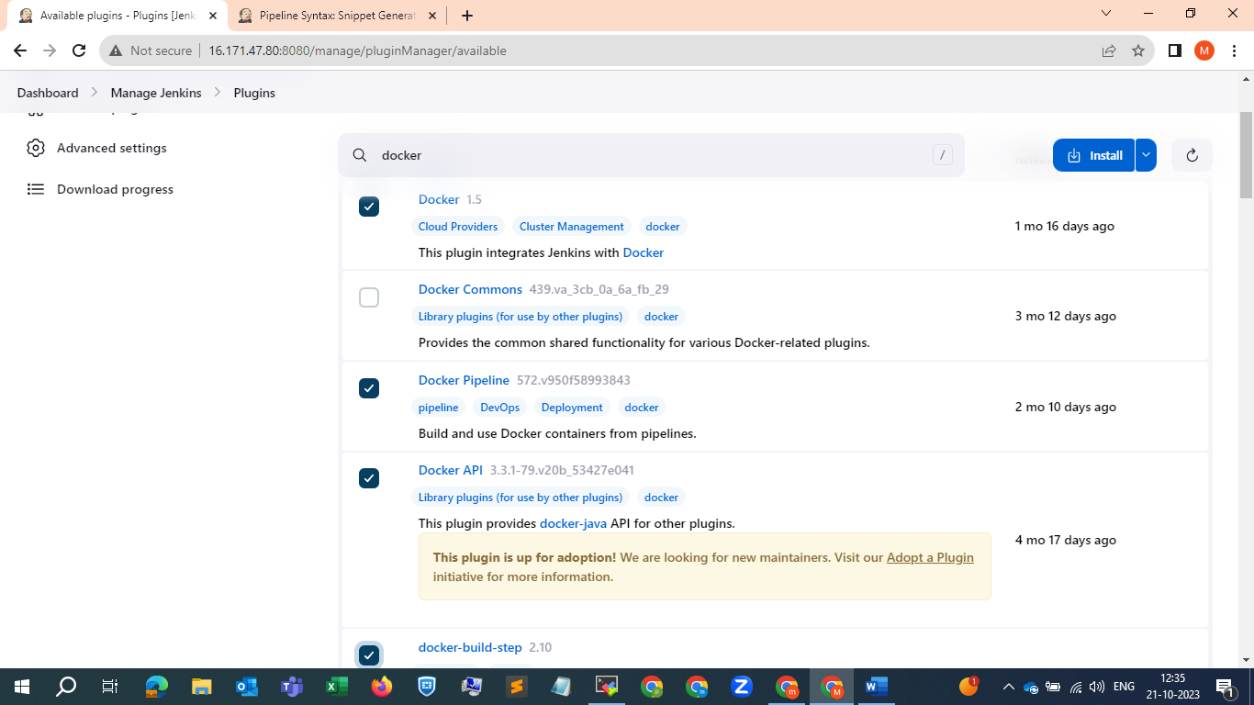

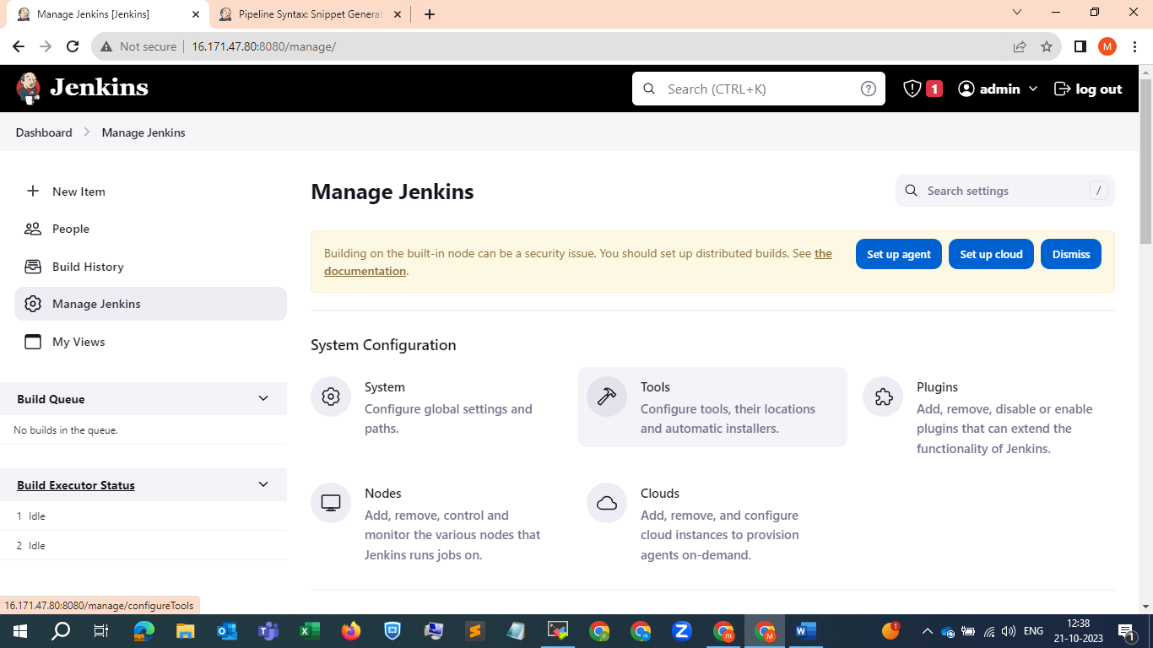

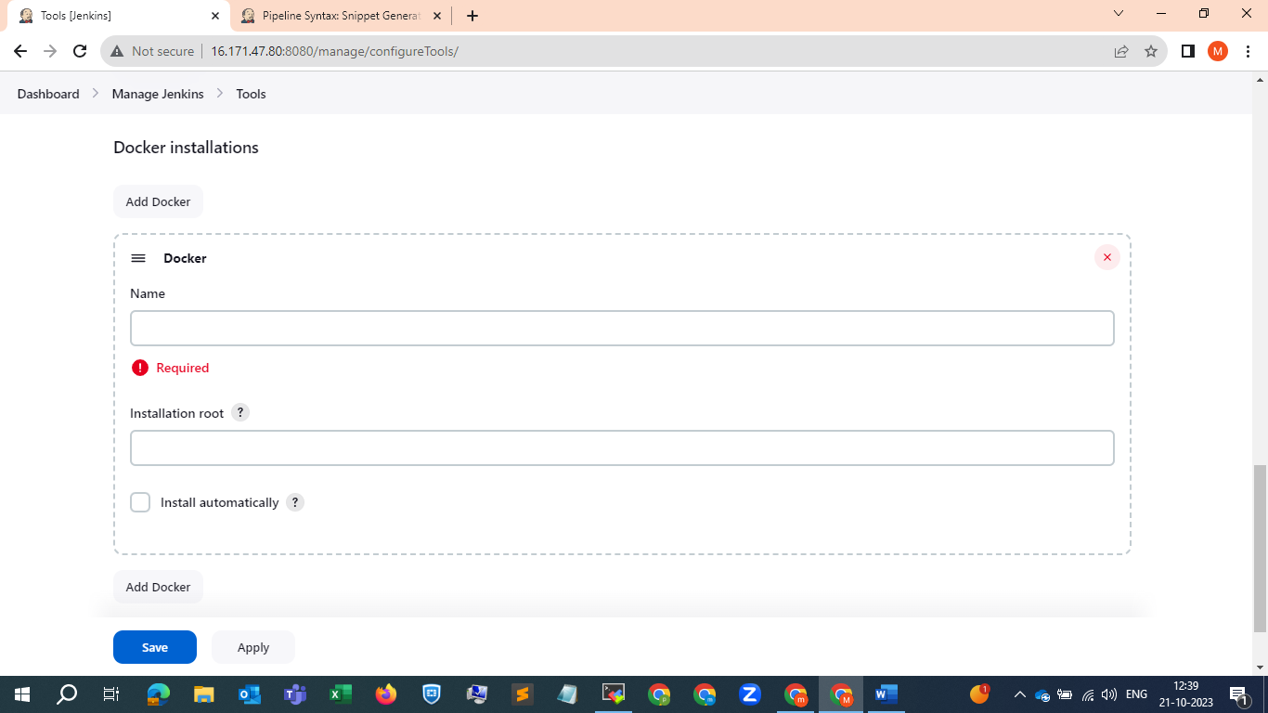

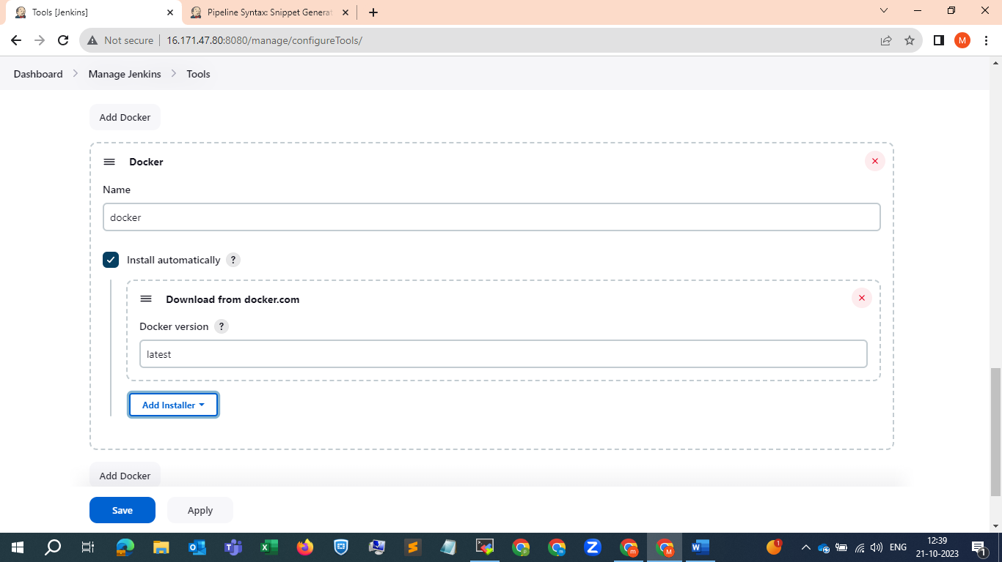

And apply and save .

Now go to credentials and do required configurations as I did in below SS .

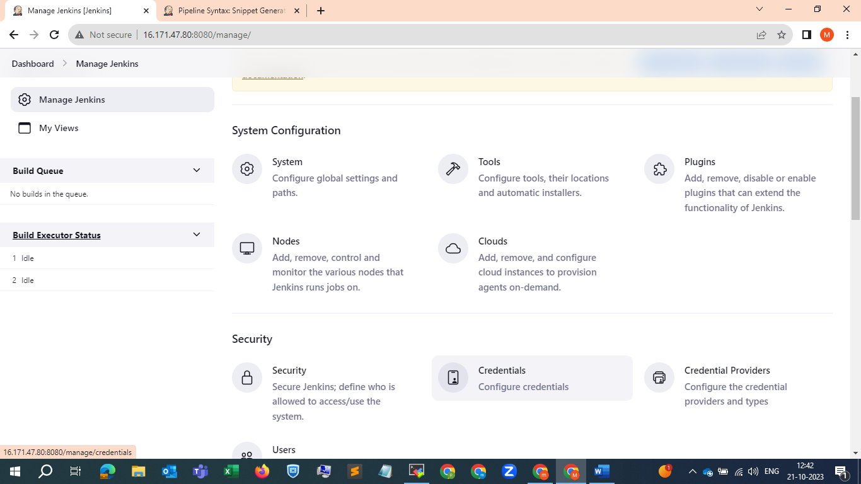

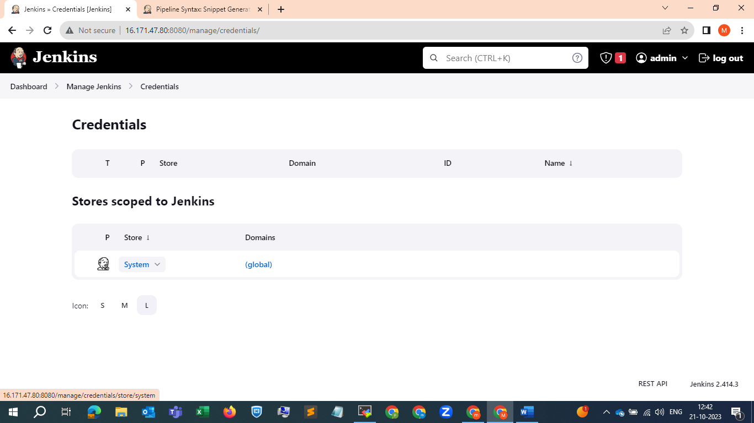

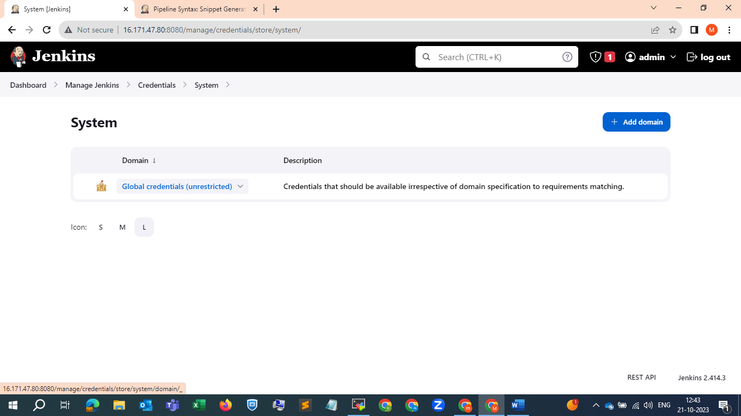

And click on add credentials

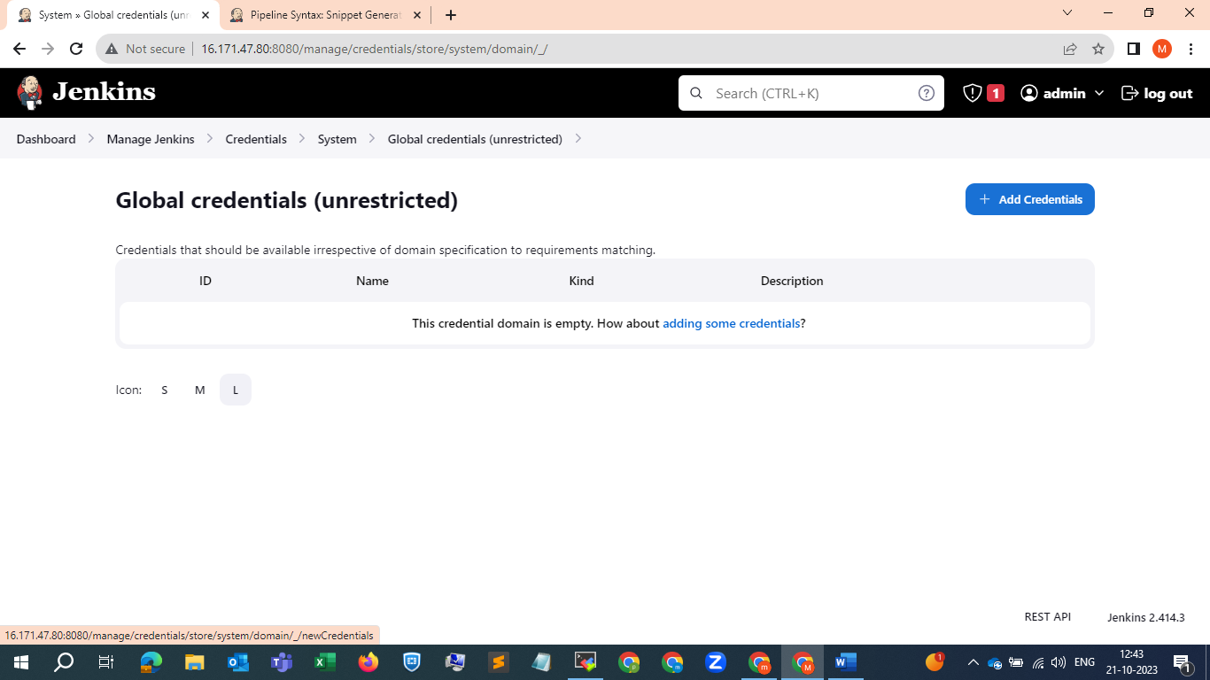

Now go to ur docker hub and copy your username and password from there

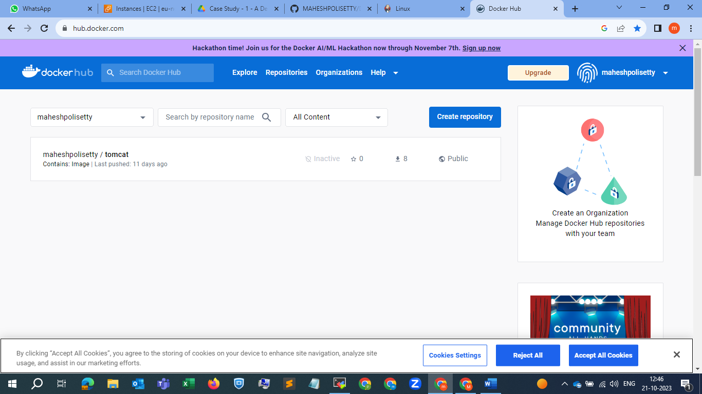

And update those details

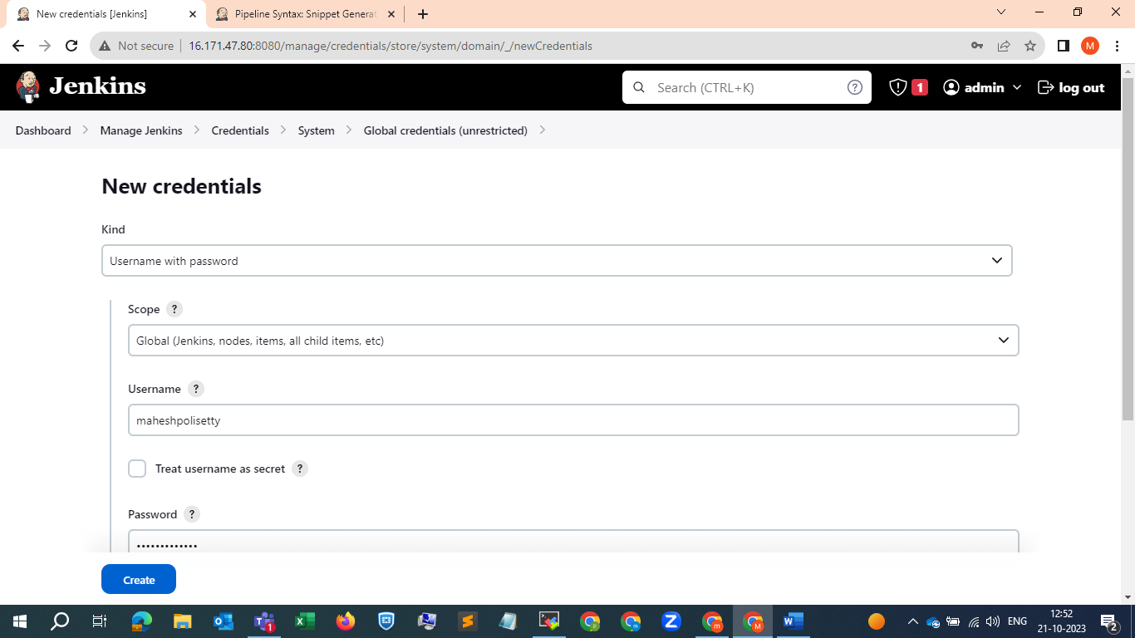

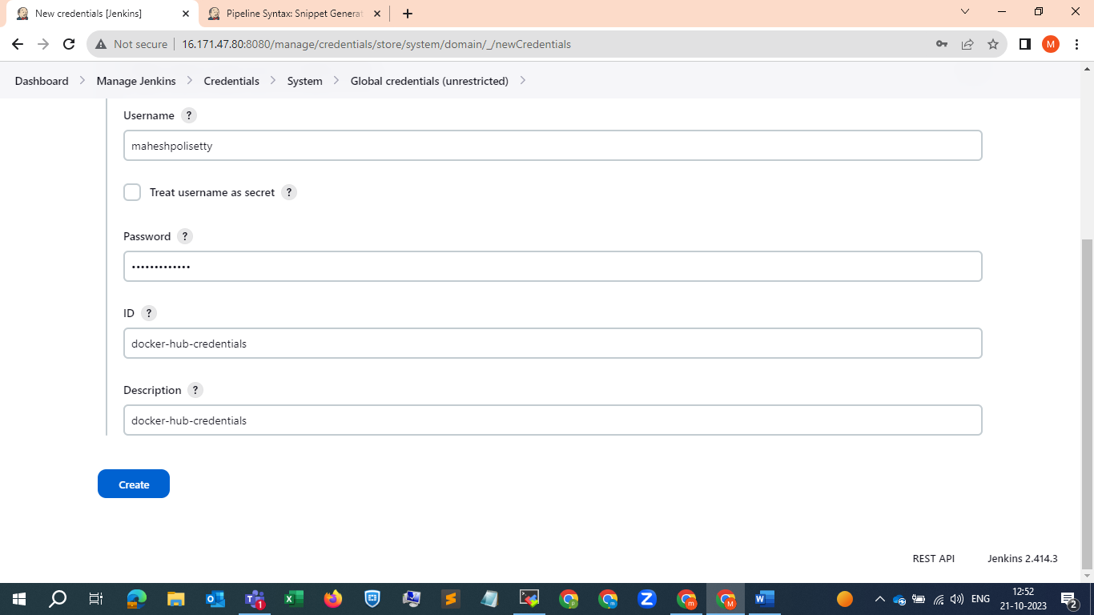

And create

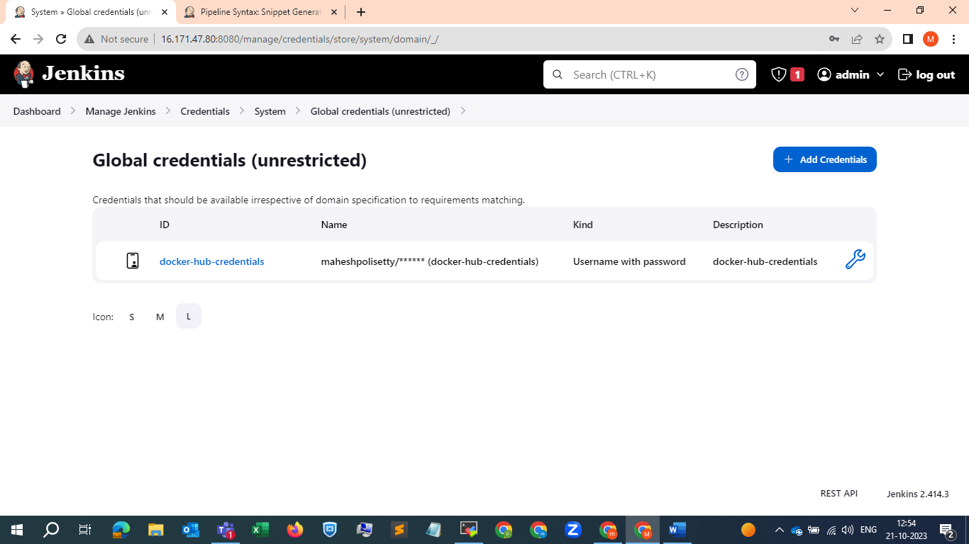

Next jump into the pipeline job and configure

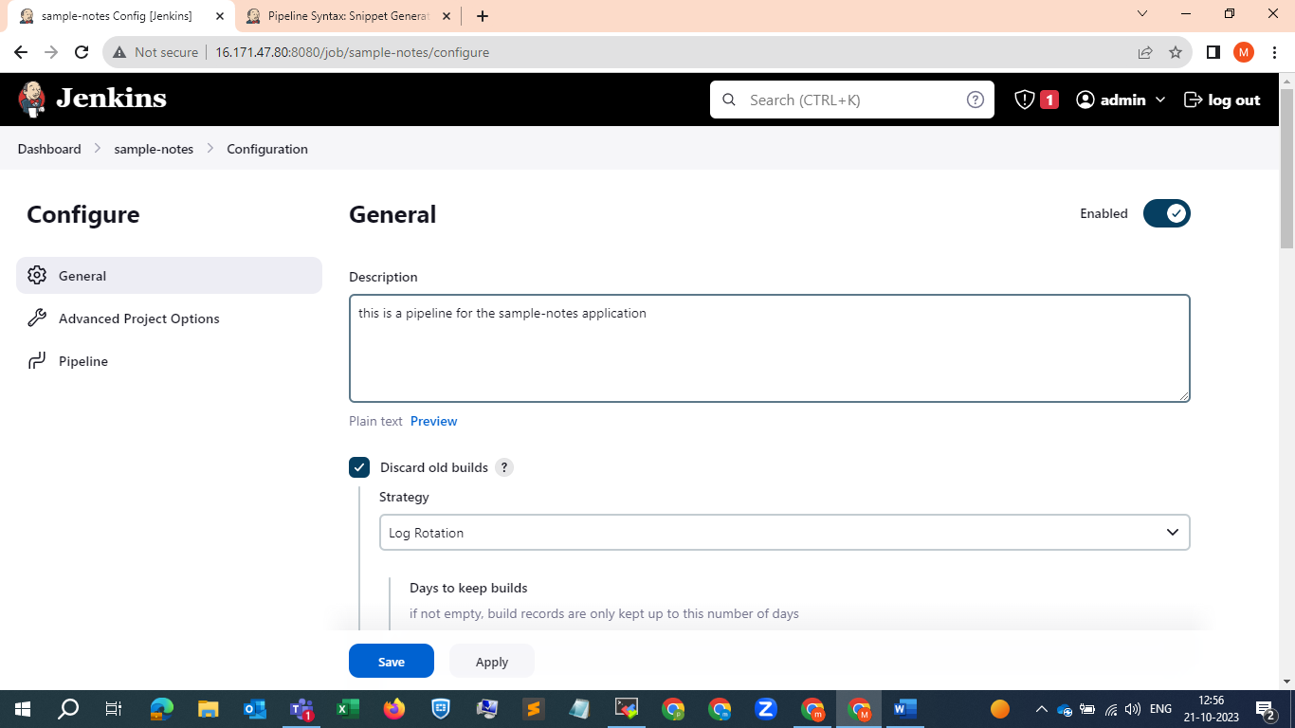

Select git hub hook option as shown in SS

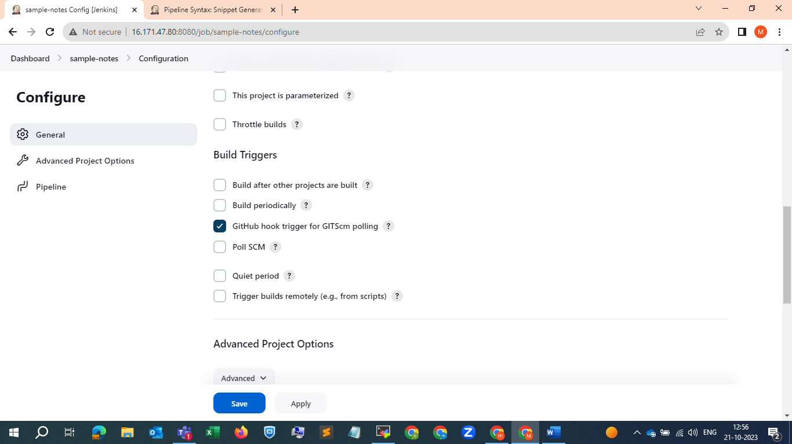

And select apply and go back to git-hub and create a web-hook under settings🡪 webhook as shown in below SS . 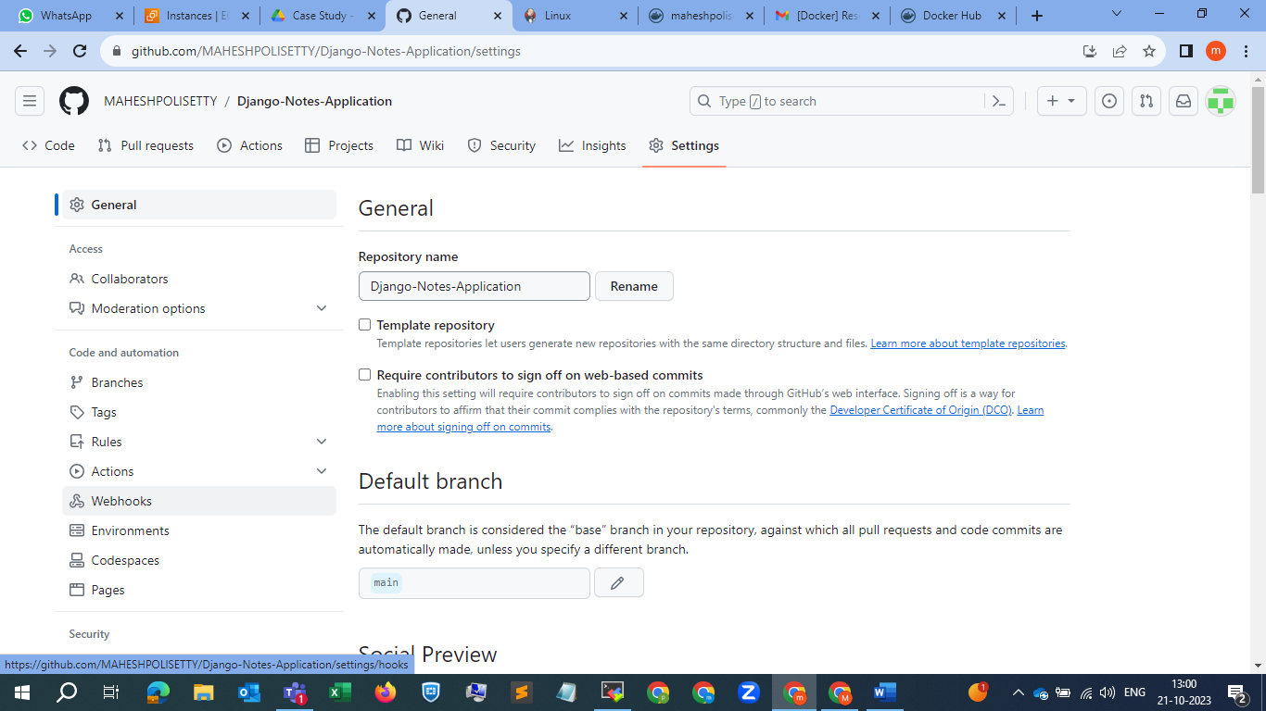

Click on add web-hook and configure a web-hook as shown below



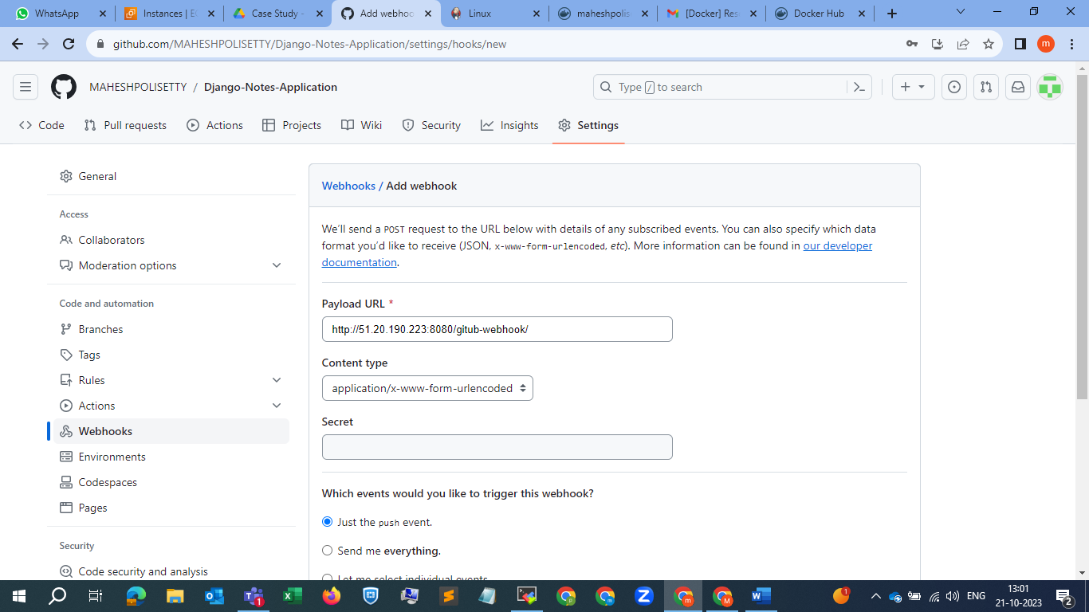

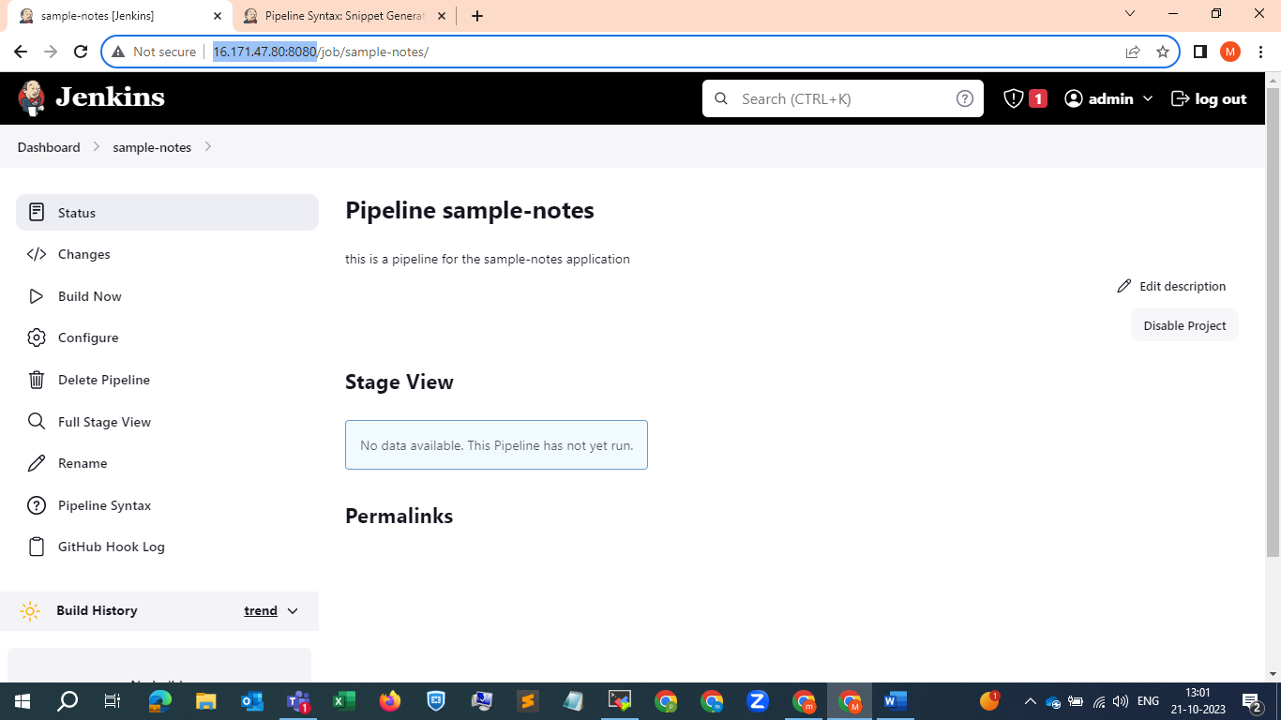

Copy the Jenkins ip along with port and paste it there .

And click on add webhook

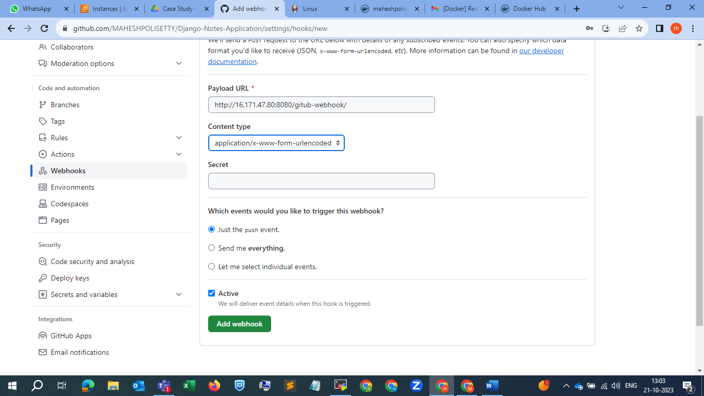

Before setting up a new docker server and hosting in that server we , will try to build it in this server , lets trigger the pipeline , after that will trigger it through git-hub commits .

Now click on build now

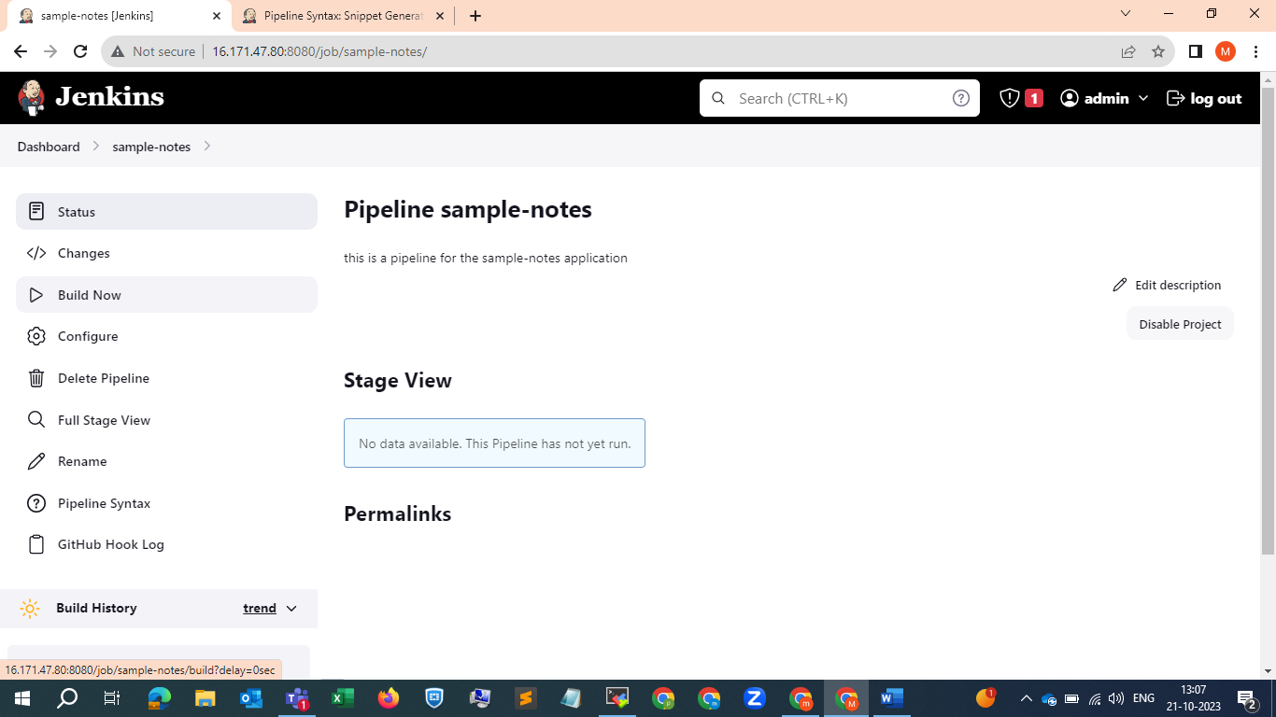

It got failed within a second and showed that there is a groovy error. Seems like some problem with the braces in the script lets try to sort it out , and will build it again .

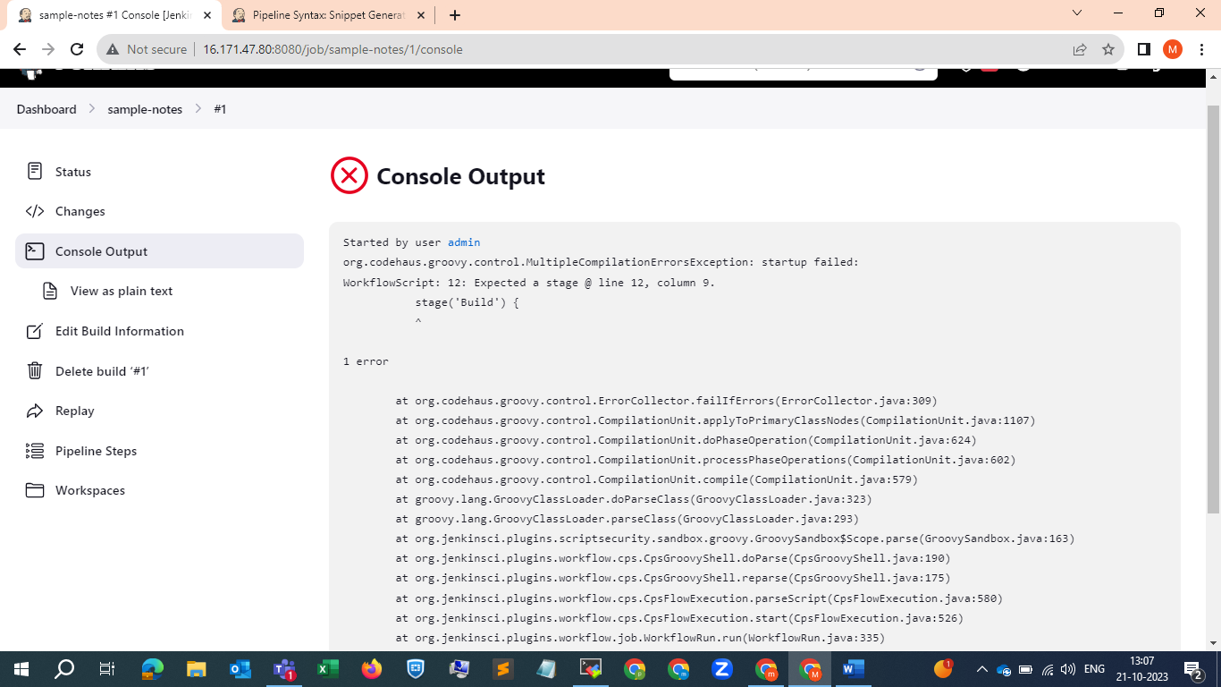

We can see now the error is different

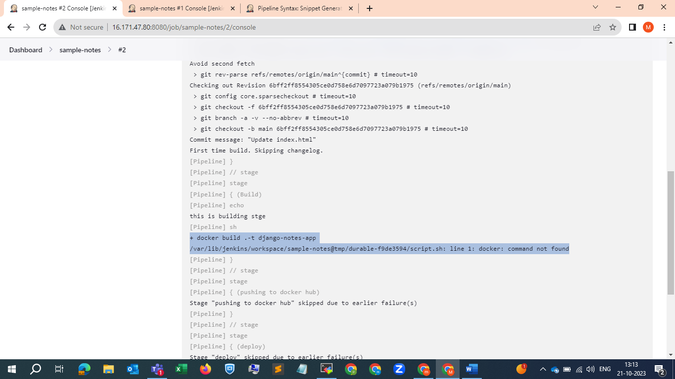

We will modify it again . and see …

Have modified it as shown below SS …. And gonna trigger it again

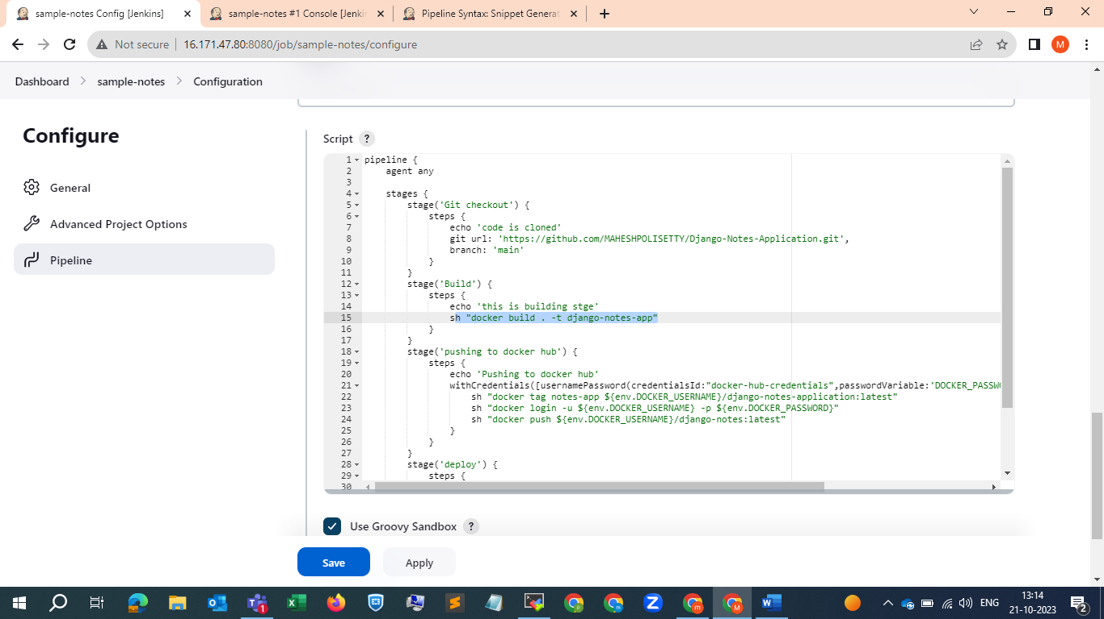

Okay it is telling command not found lets install docker in the Jenkins server and will try it once again

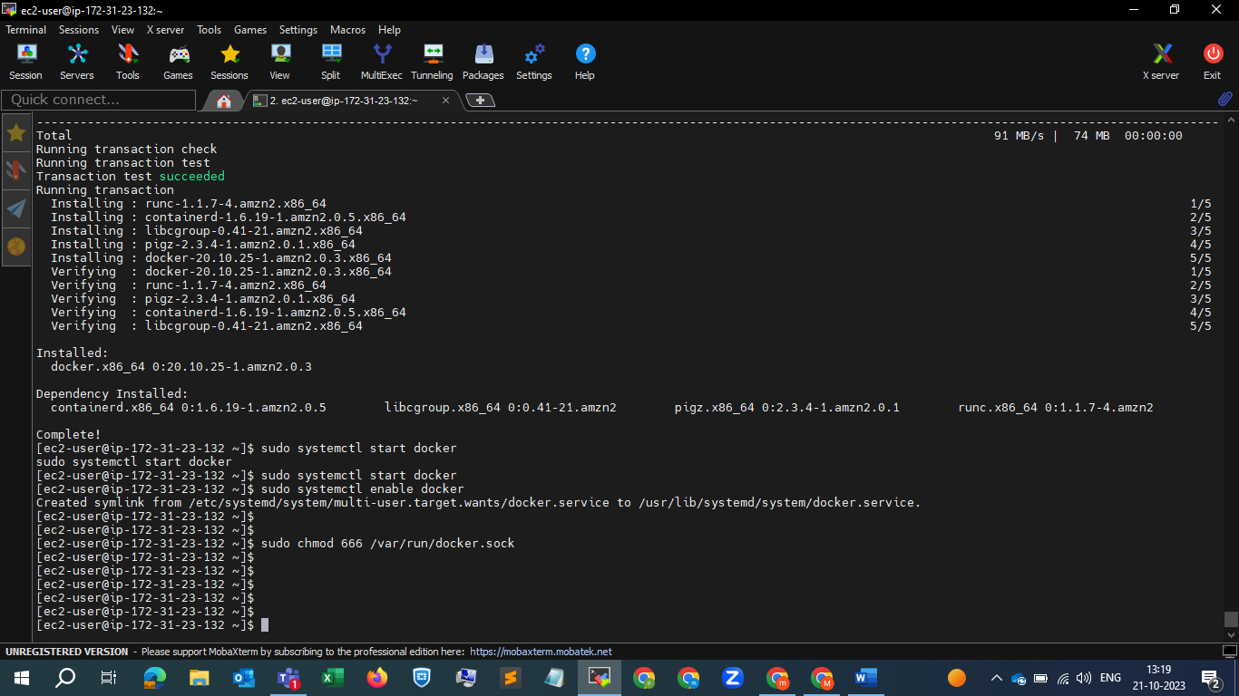

We have installed docker enabled , it and started and given permission to the /var/run/docker.sock file also

Lets restart Jenkins and server once and will try to build it again ….

And we can observe here in 5 th build that it is showing that it got failed at third stage (pushing stage)

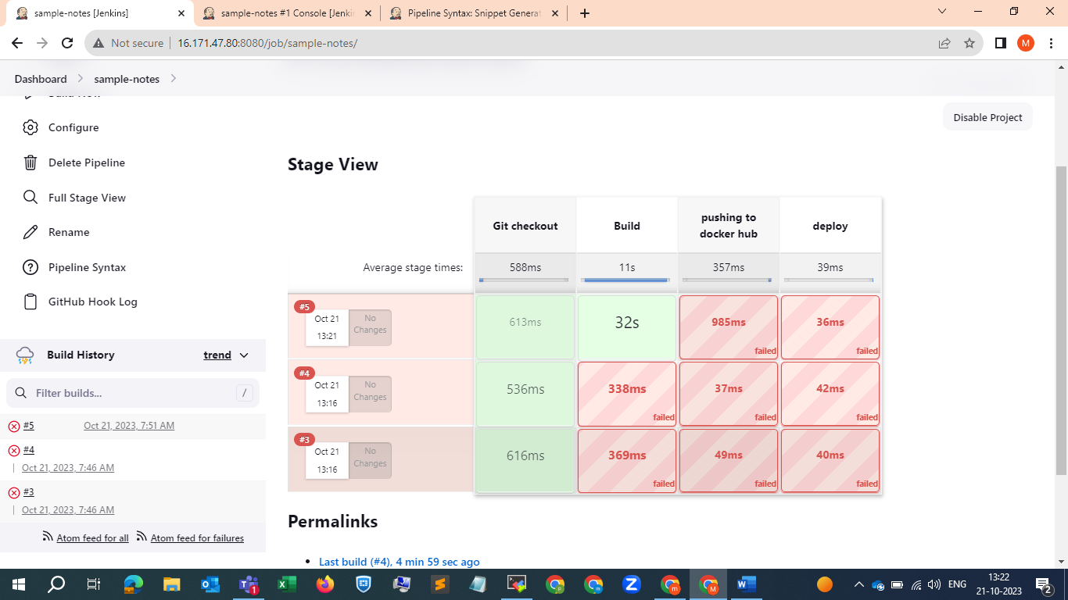

Now will go and check what is the error

It is showing that no such image means , we have to modify the image name it seems …

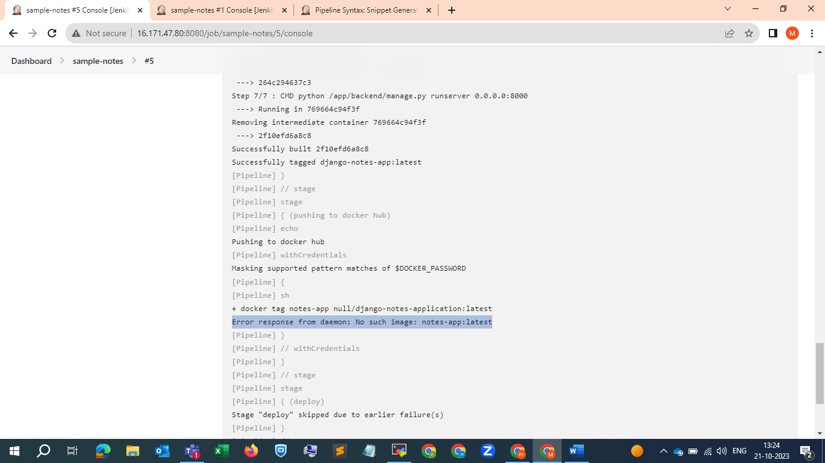

We need to put the Django-notes-app I think , we will try this method also once .

See here we have given the name wrong

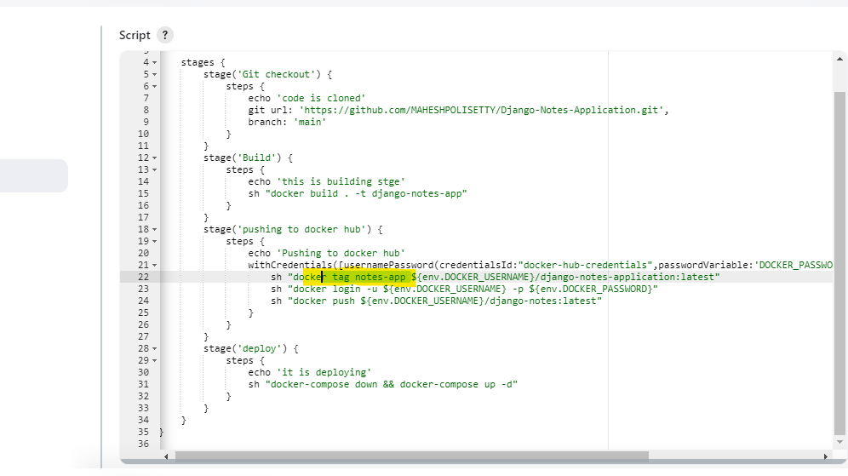

We will correct it and build it again

We now got the different error .. we can see the older error is gone

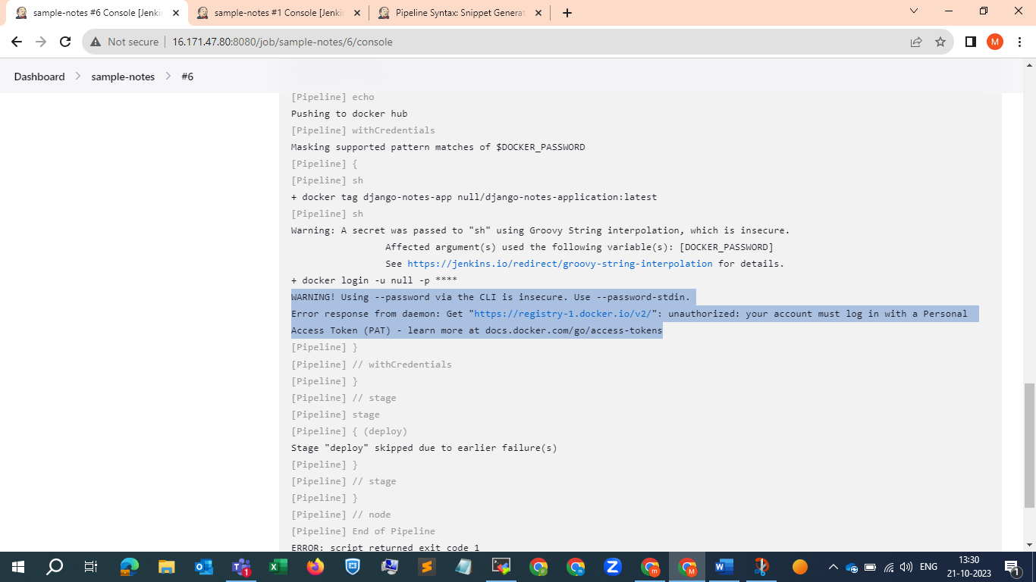

Now for this we have logged into docker in the Jenkins server

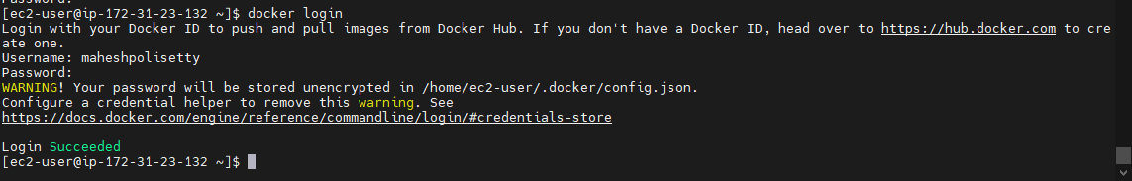

Now will build it again and will see …

But not resolved .. showing the same error

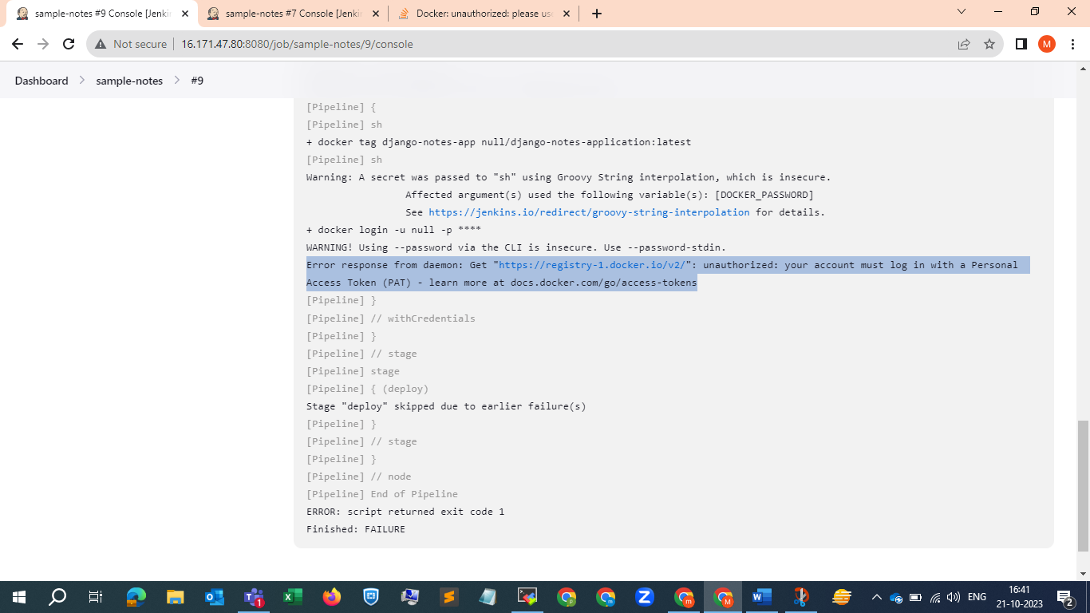

We will try once by setting up the token , here we have to create the token and in the place of pa

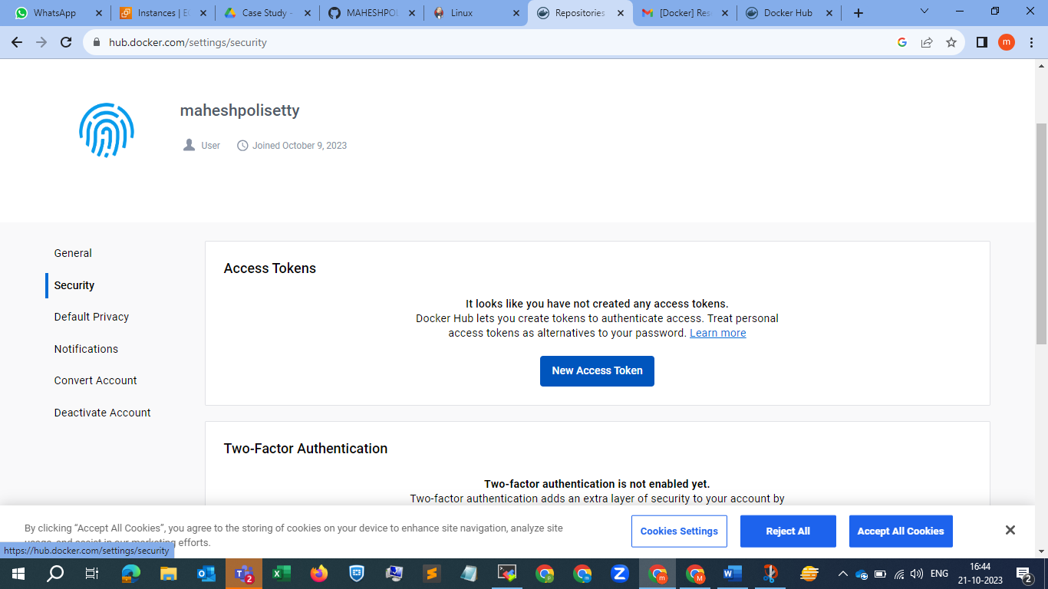

Now we have created token logged in using PAT token, now we will try once again by restarting docker . it is also not working .

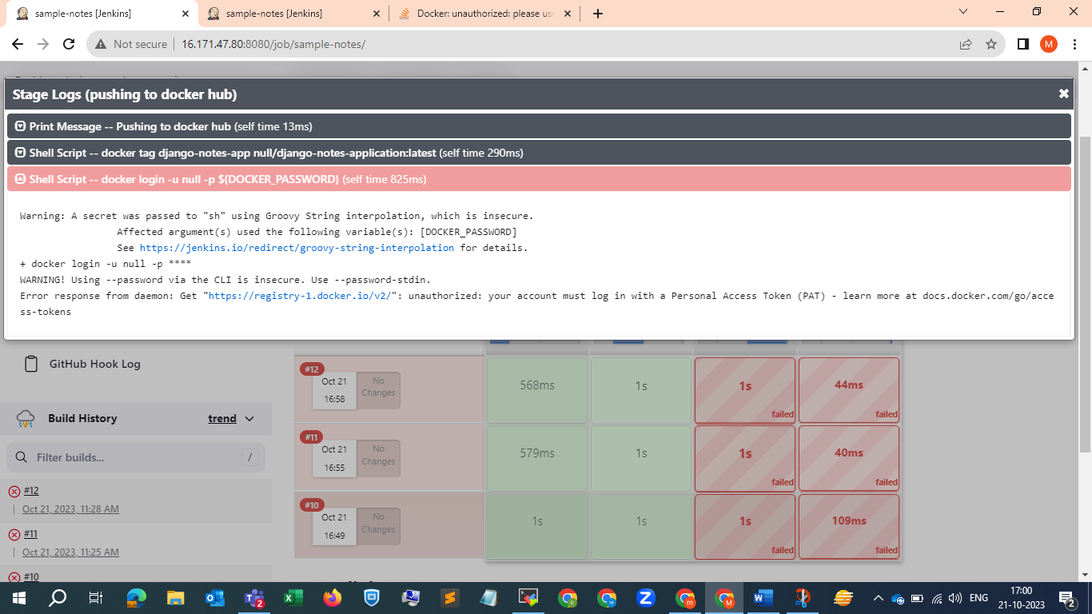

Will do one thing I m removing this sh "docker login -u ${env.DOCKER_USERNAME} -p ${env.DOCKER_PASSWORD}" line from the cript as I already logged into docker in the Jenkins master server .

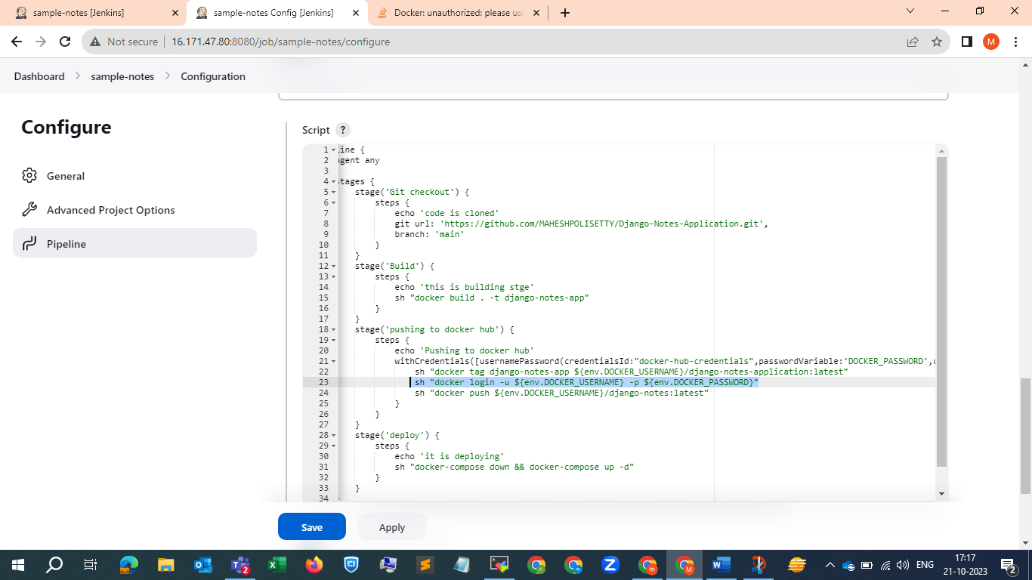

See the error is now different . 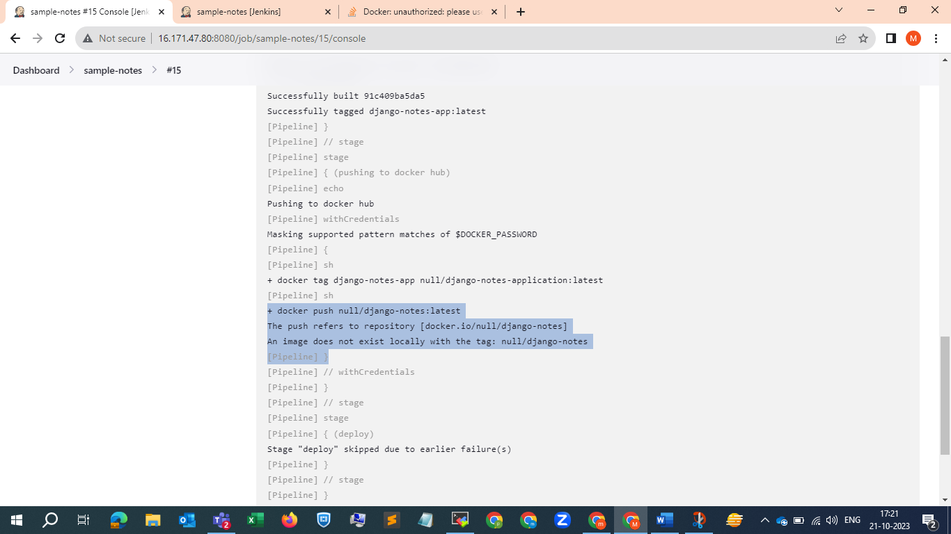

Here our mistake is while defining username variable we have given wrong name also after the Django-notes-application name also given wrong . so pls be careful while duilding ,

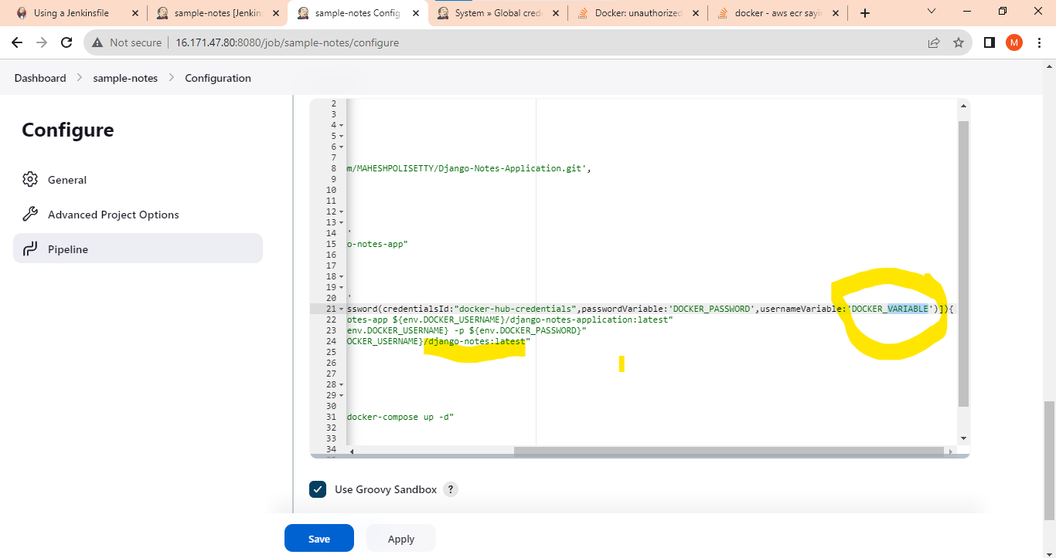

Now corrected and running , the pushing stage also completed now . at the 33 rd build . u can see it down here in SS .

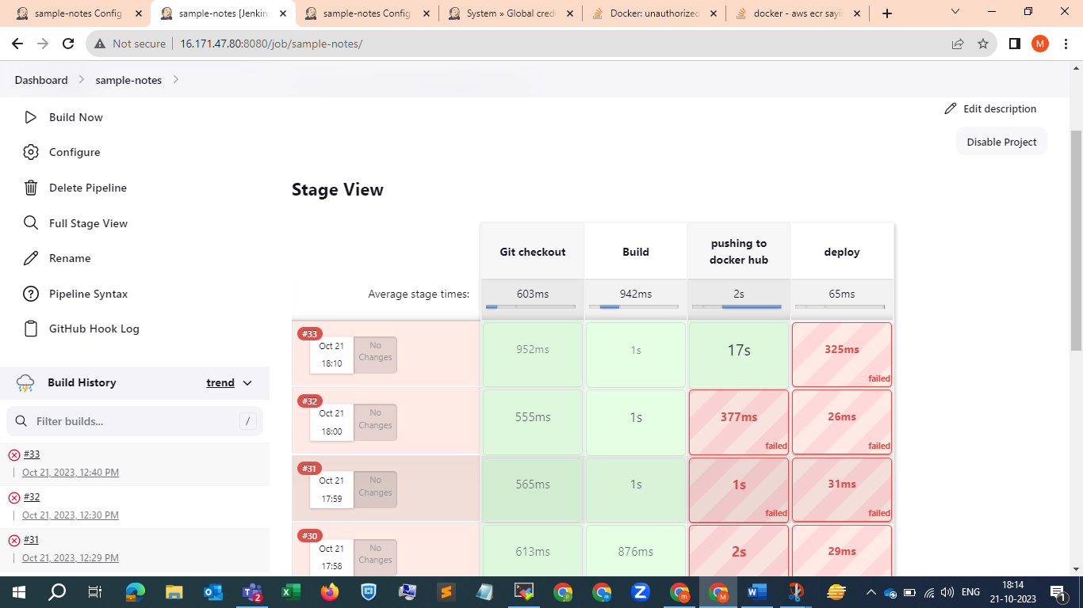

As it is showing that docker-compose is not installed . Now we will to install docker-compose in the Jenkins master only and will host the application here itself after that we can set up a slave and will host on that server

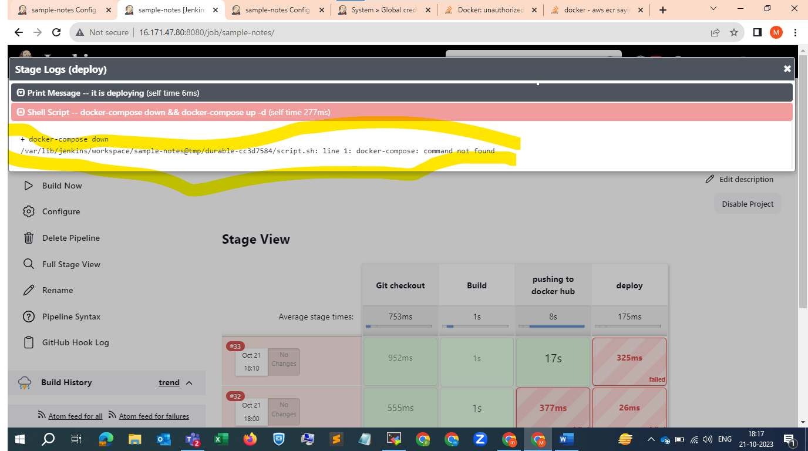

Installing docker-compose on ec2

<https://docs.docker.com/compose/install/linux/#install-the-plugin-manually> and

<https://docs.docker.com/compose/install/standalone/>

pls refer these 2 links

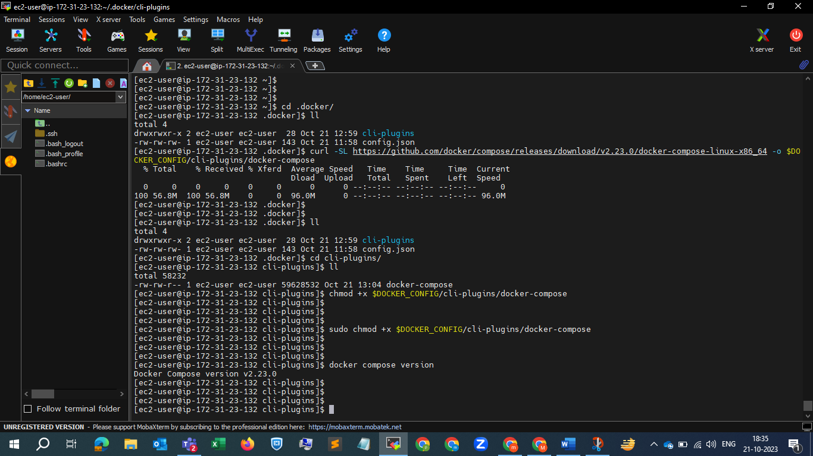

And docker-compose installed successfully .

Now we will try to build it again and see what will happen .

Now everything went fine but at the end due to space issue it failed , we will deploy it in a different server 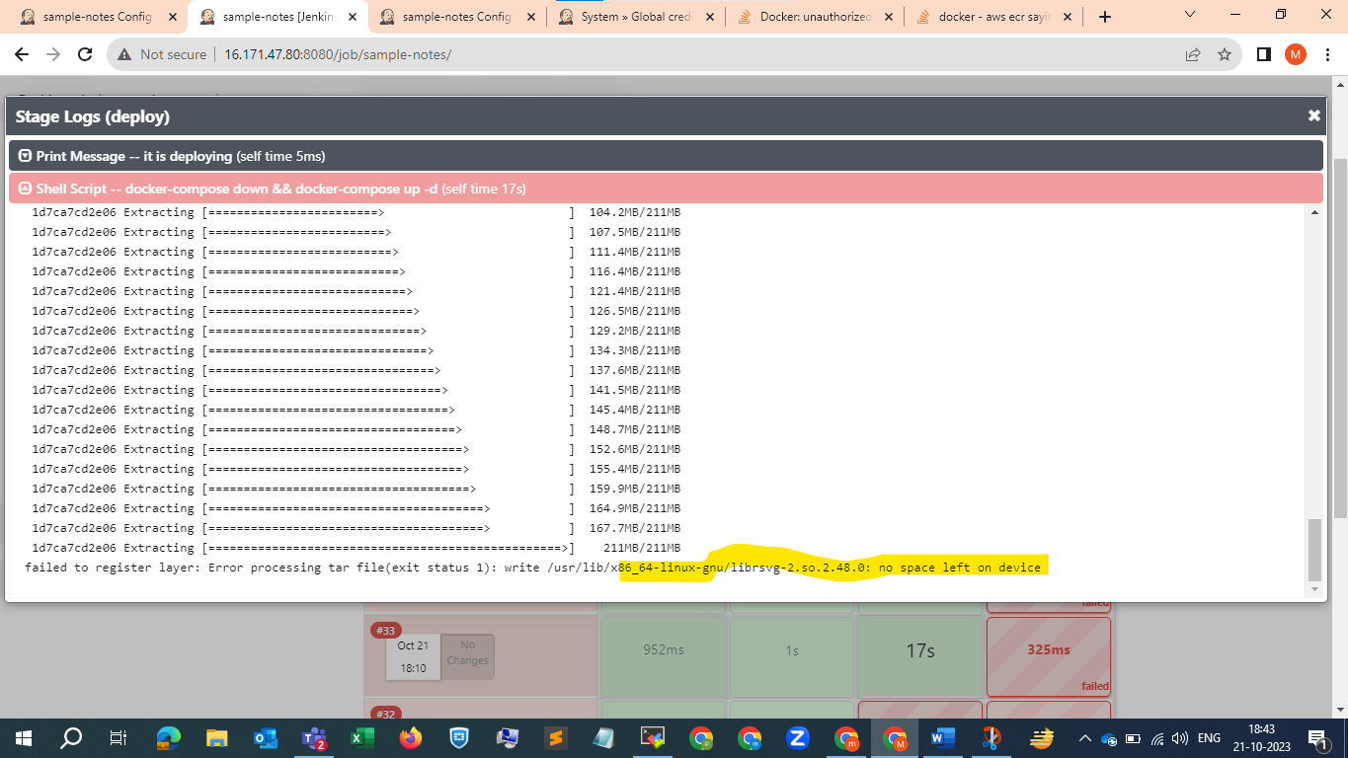

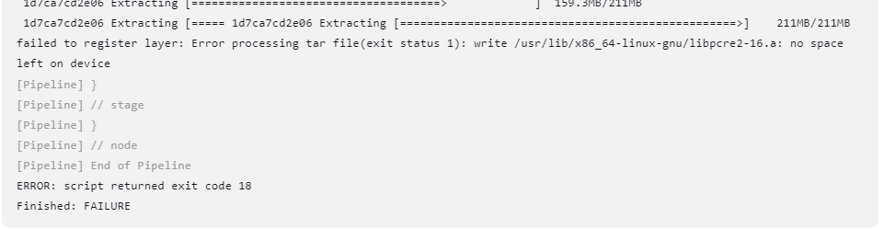

For cleaning up all dead containers and useless images we can use the following command

sudo docker image prune -f && sudo docker container prune -f

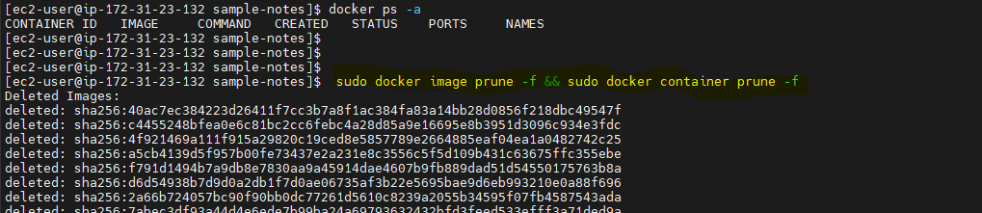

Now after cleaning some space we can see that our pipeline build is successful

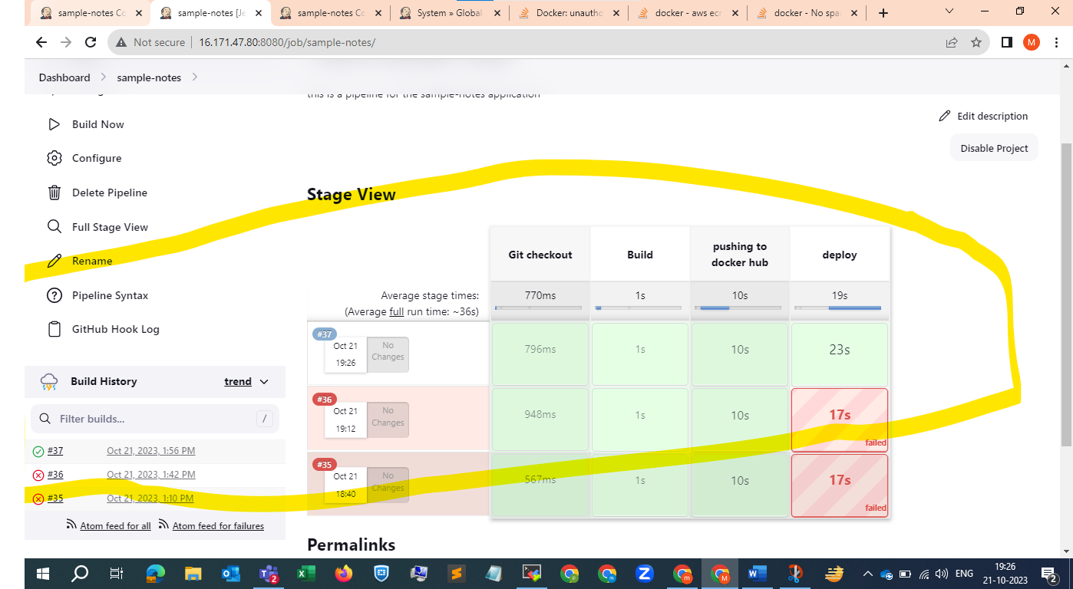

We can see it has started .

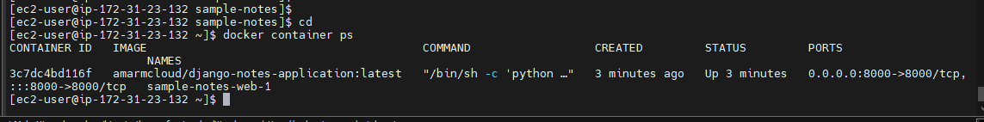

Now we will go and check in the browser , with the port 8000

Make sure you have enabled the port 8000 to the ec2 instance

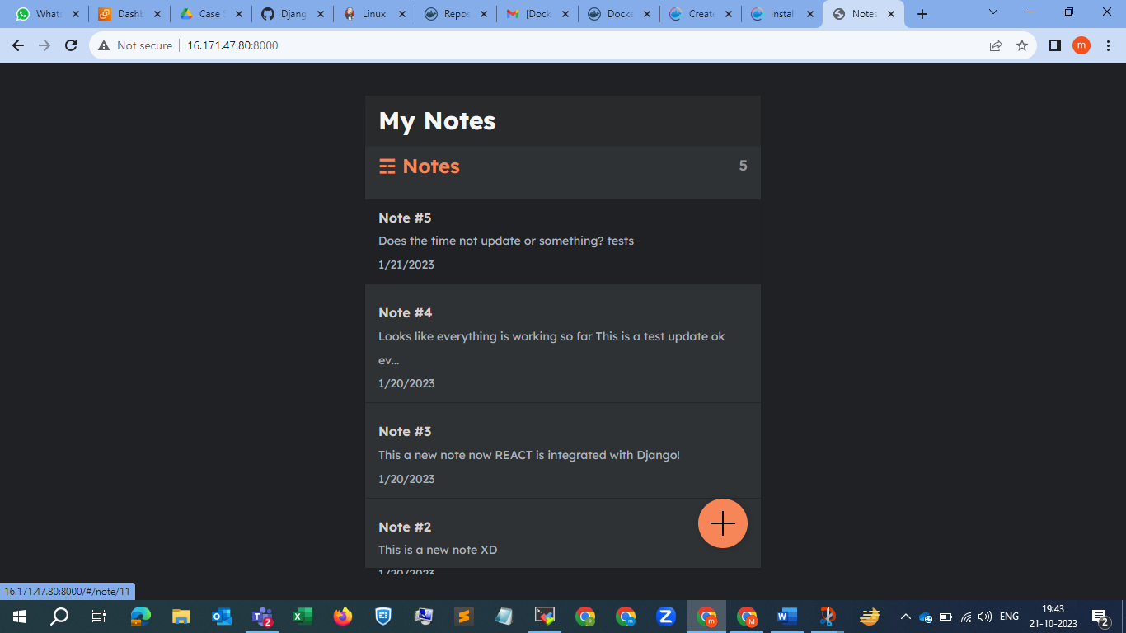

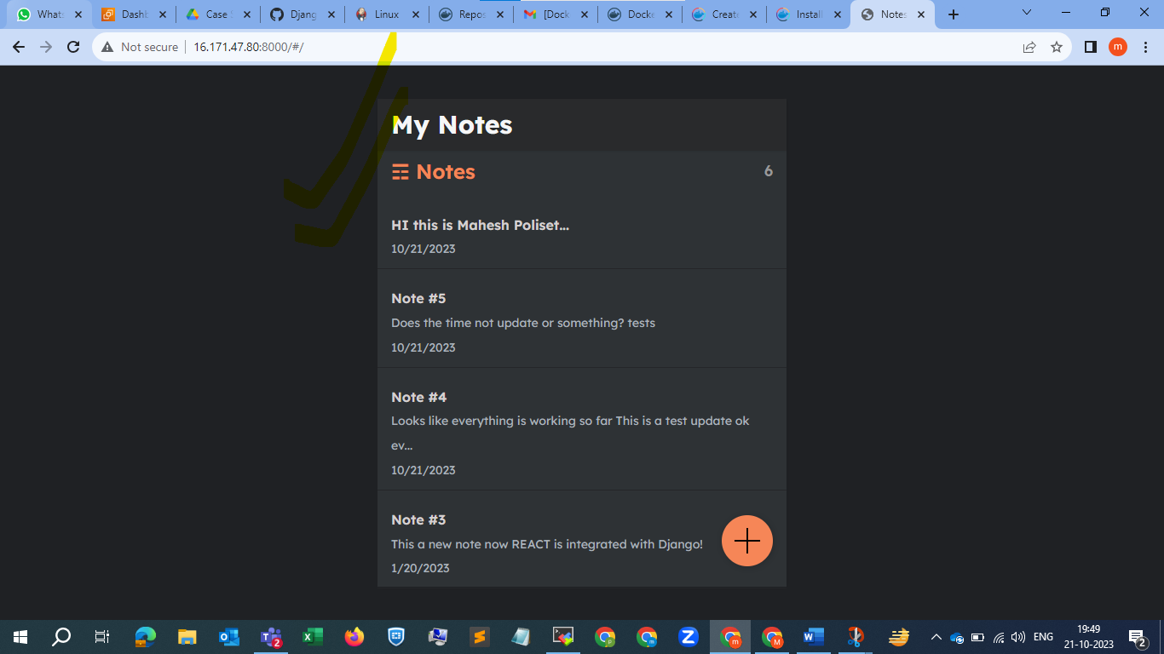

Here we go the deployment is now completed , and we are running it on the same jenkins server , as the requirement is to run on a separate server , we will configure a slave for this by making some small changes in the pipeline script .

See aas we built in the same jenkins server it is having the trouble , so we should not deploy our application in master

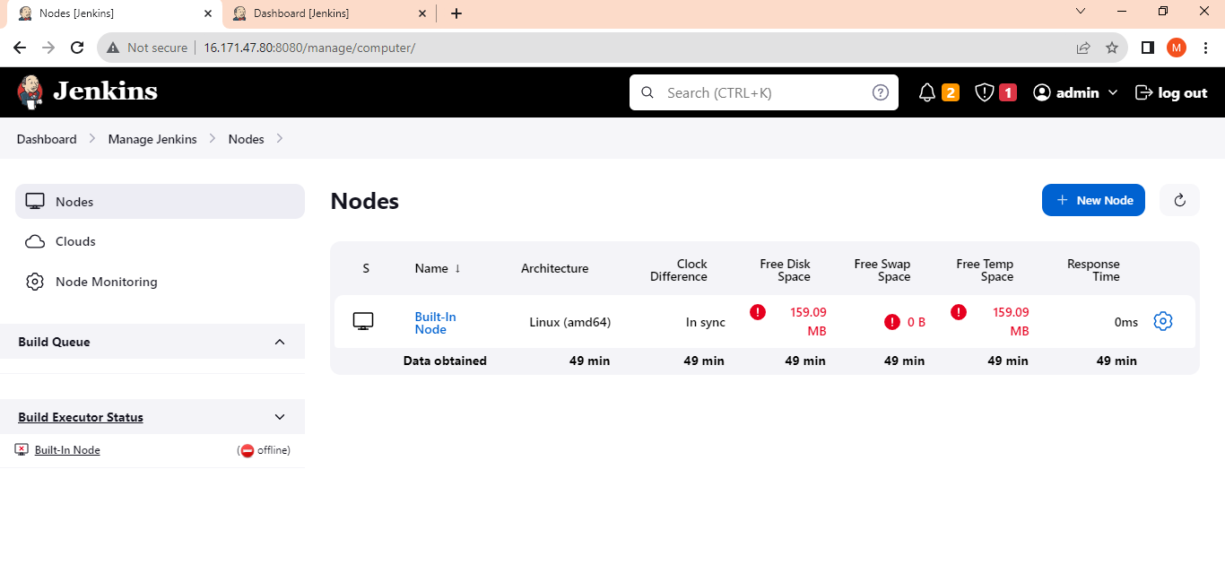

**Now we will configure the slave ec2 (deployment server ) ;**

Connect to it install java , docker and docker-compose as shown above previously

And make port 8000 is enabled for that slave server

For Installing docker-compose on ec2

<https://docs.docker.com/compose/install/linux/#install-the-plugin-manually> and

<https://docs.docker.com/compose/install/standalone/>

pls refer these 2 links

after that we need to generate ssh public and private authorization keys pls refer below SS .

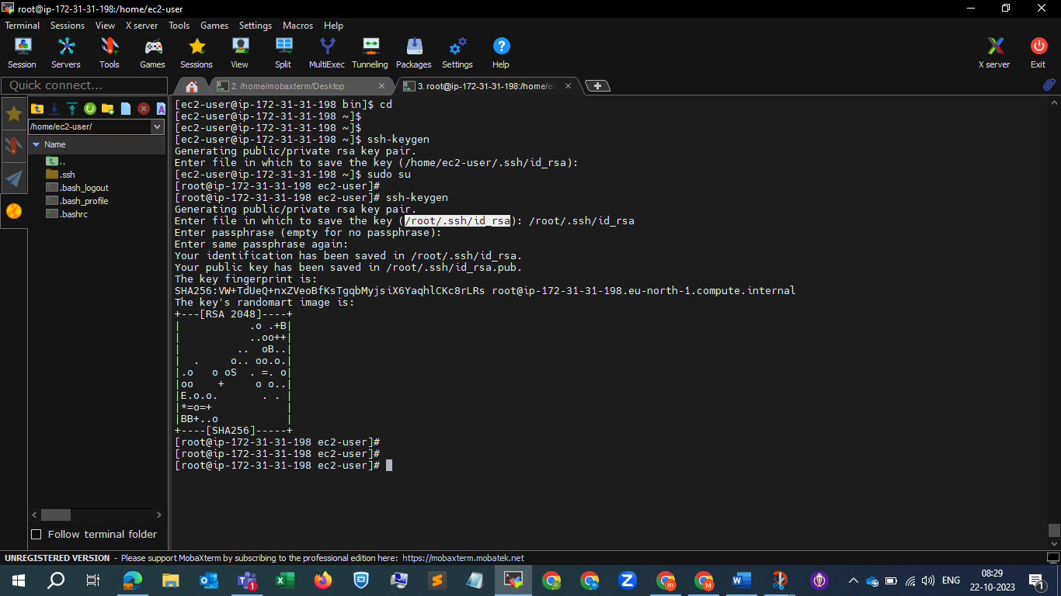

And paste the the content of the id_rsa.pub in the next line of authorized_keys file for authorization which we will get to kone while congiguring the slave node 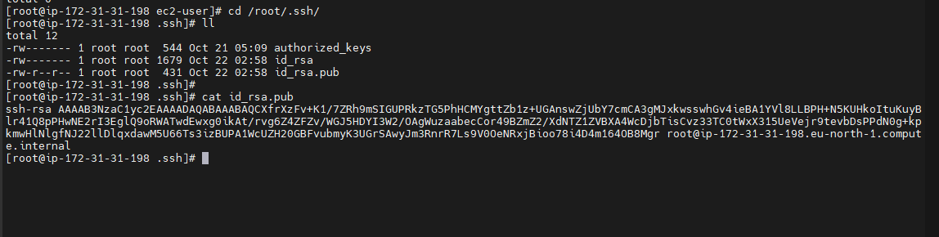

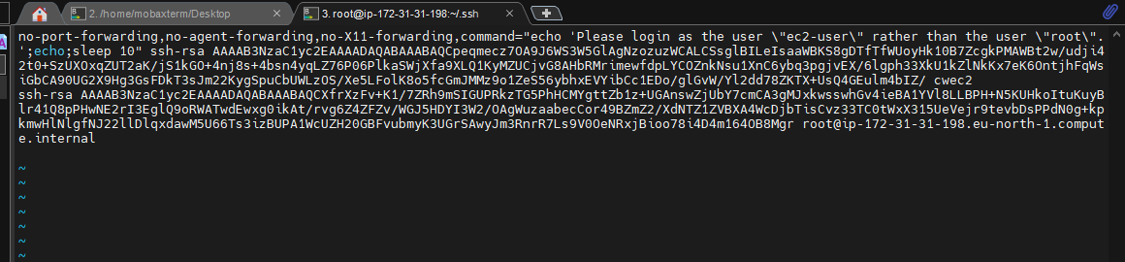

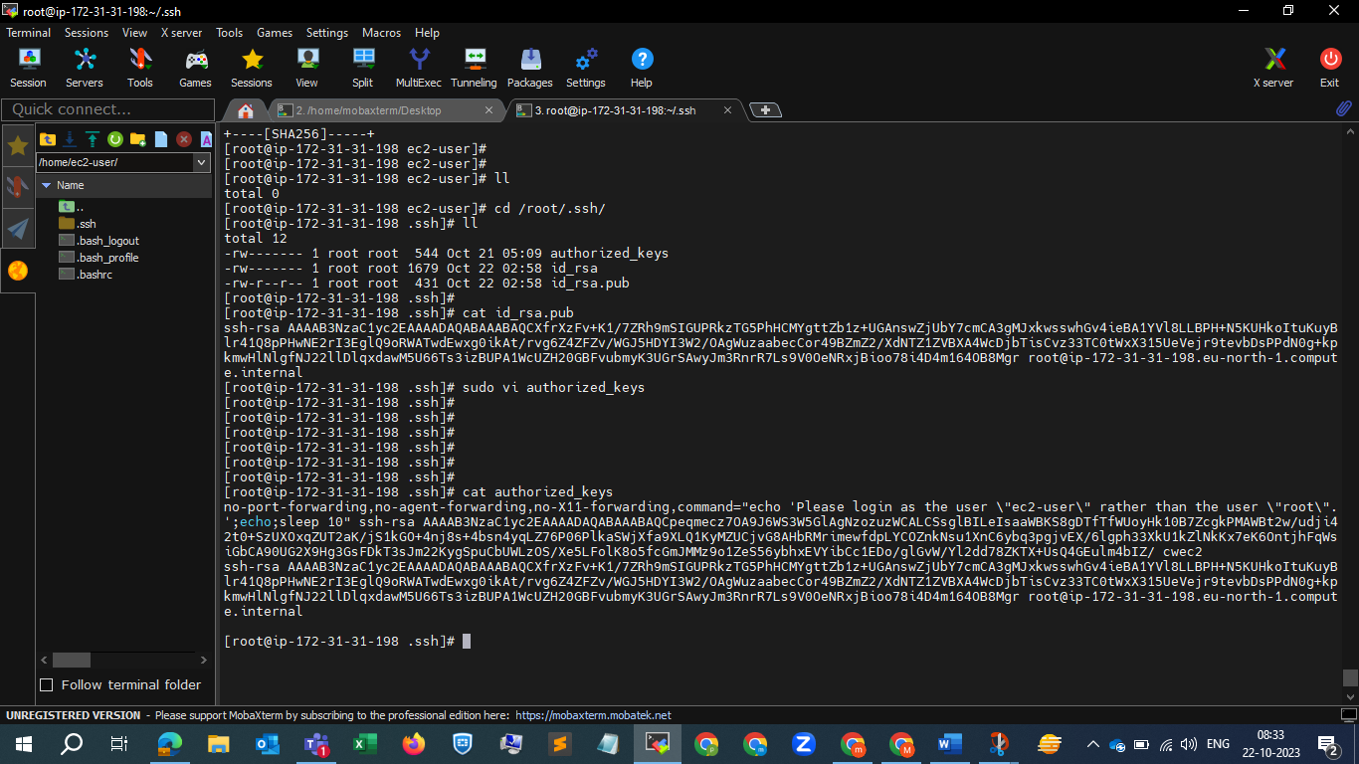

Now go to home directory and create a workspace directory for the slave where all the commands that we run on master are to run application are stored. This is also called as the slave root directory.

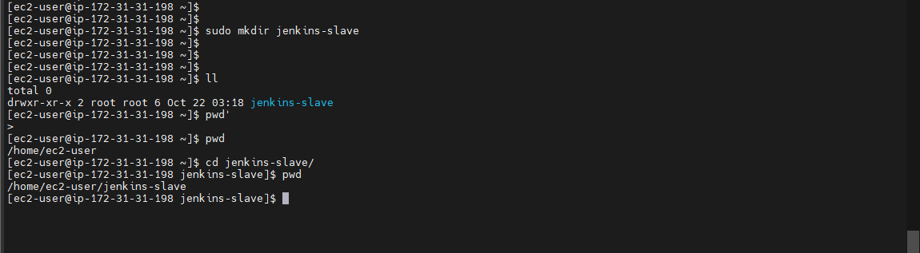

Now all the configuration is done in deployment slave server . now we will set up this slave in Jenkins. Pls refer below SS .

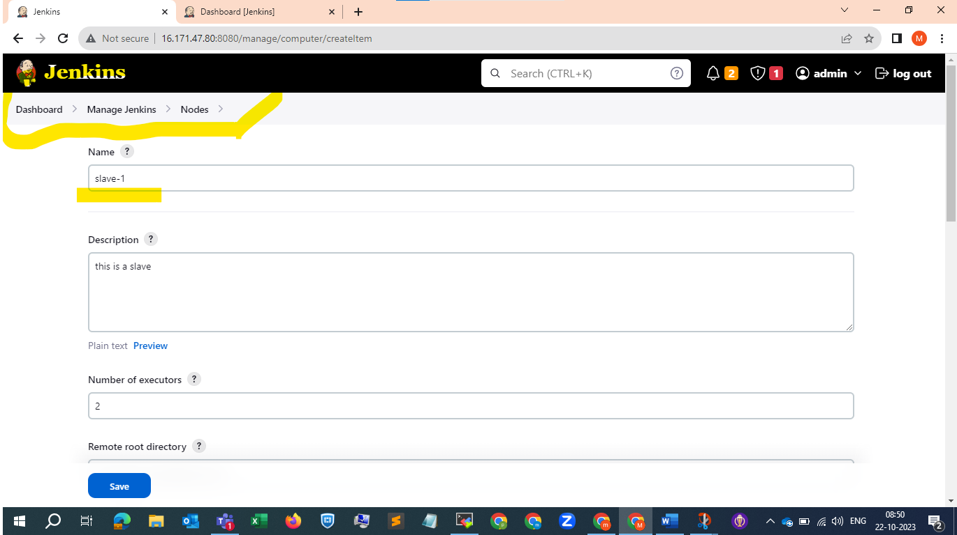

This section is very important

Under launch method We have to select launch agent via ssh

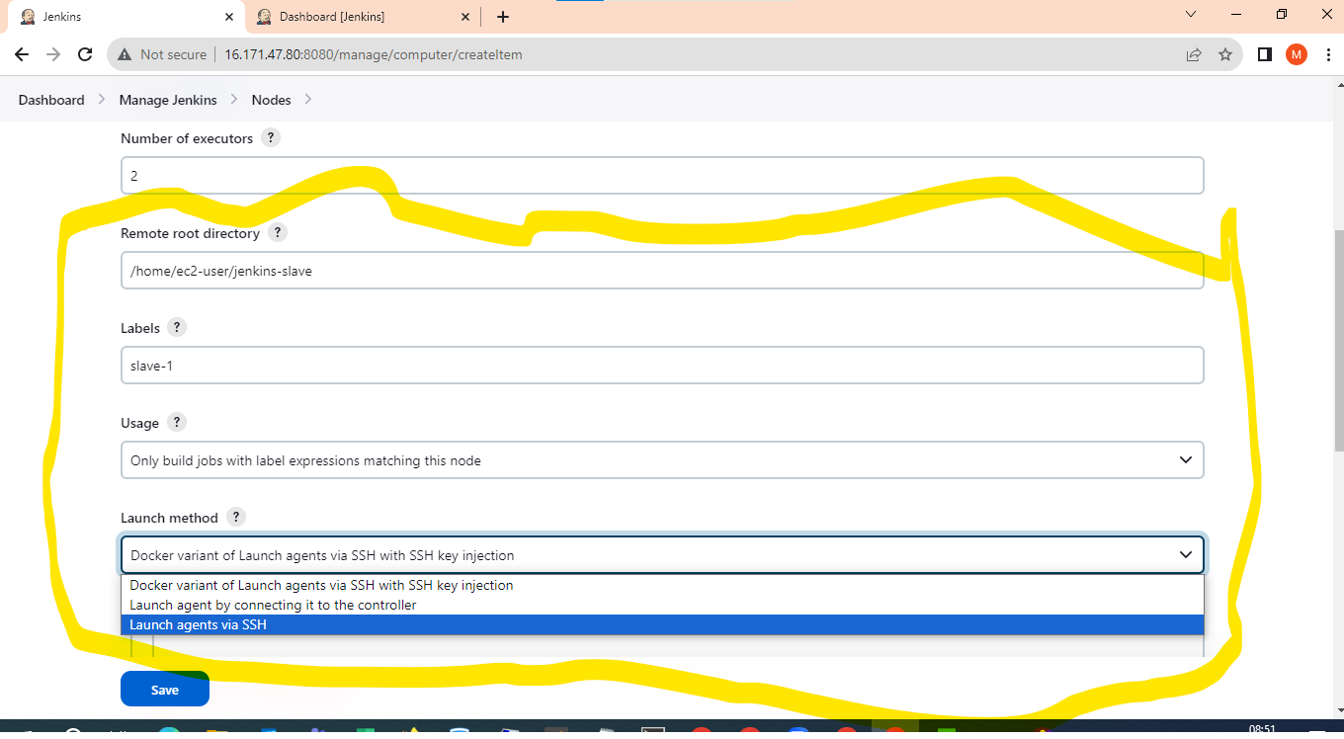

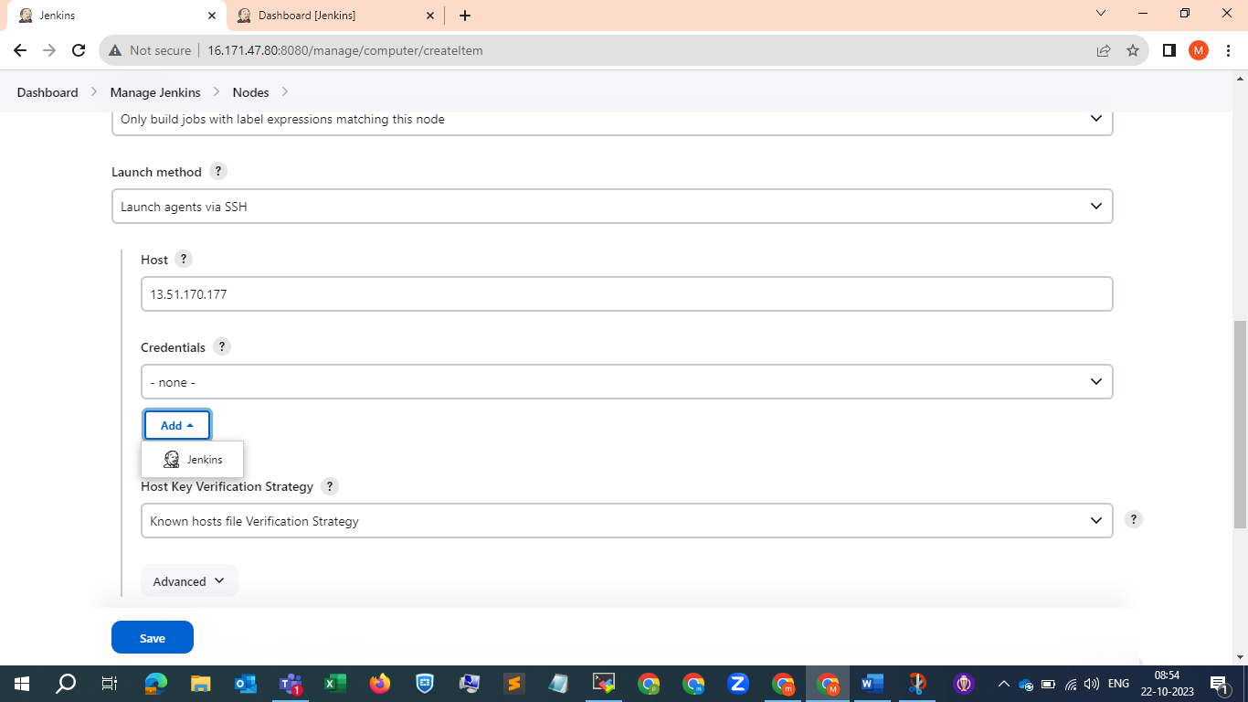

We need to cofigure the credentials here the private id_rsa (key) file content we have to copy here .

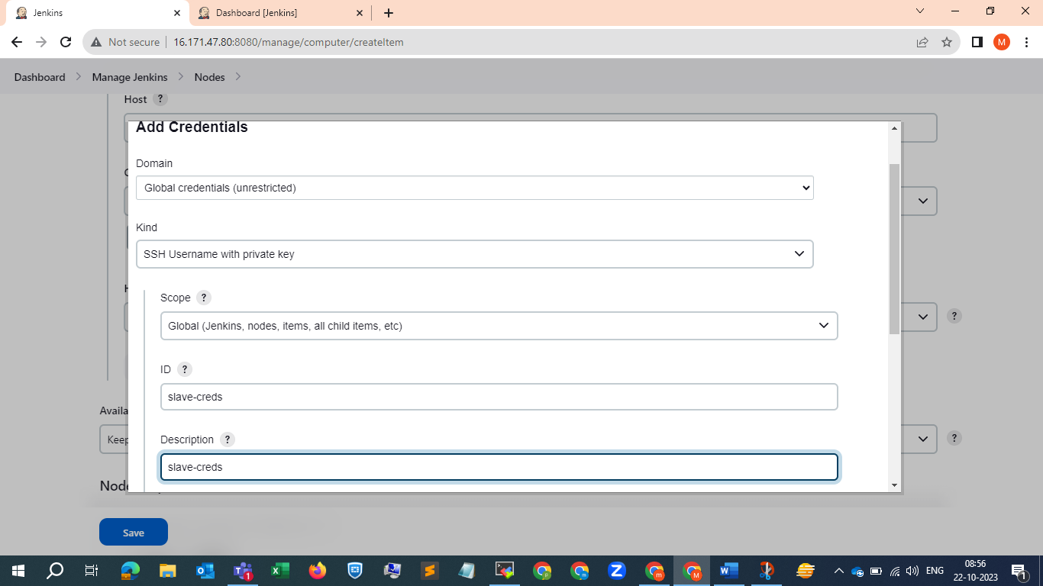

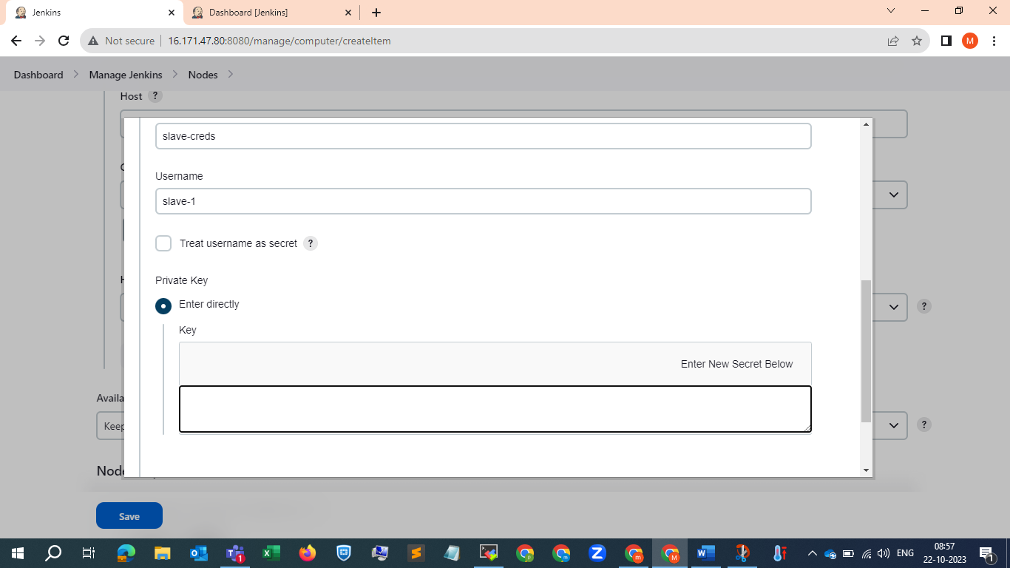

This key

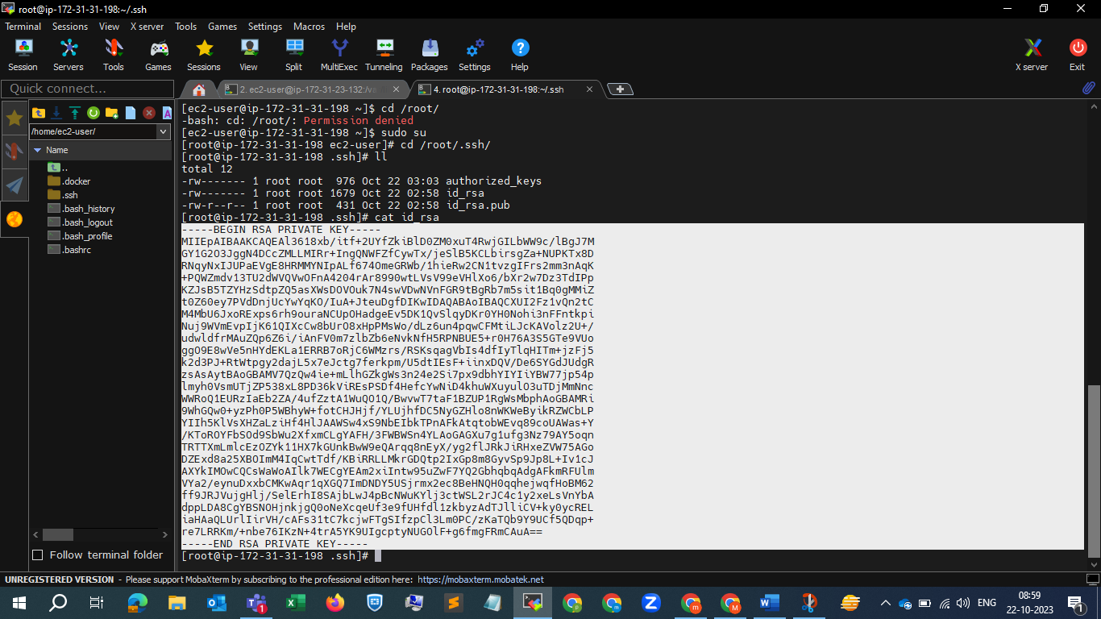

And cick on add button

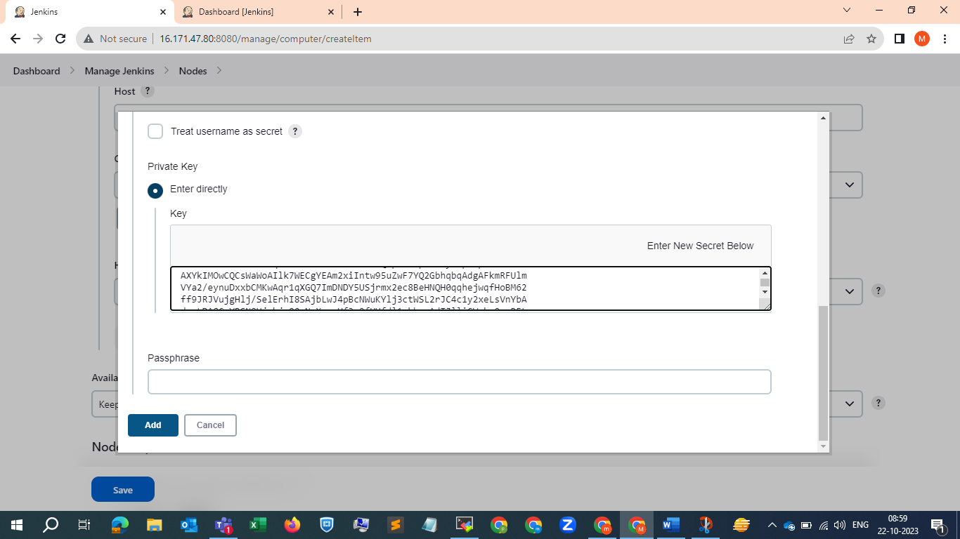

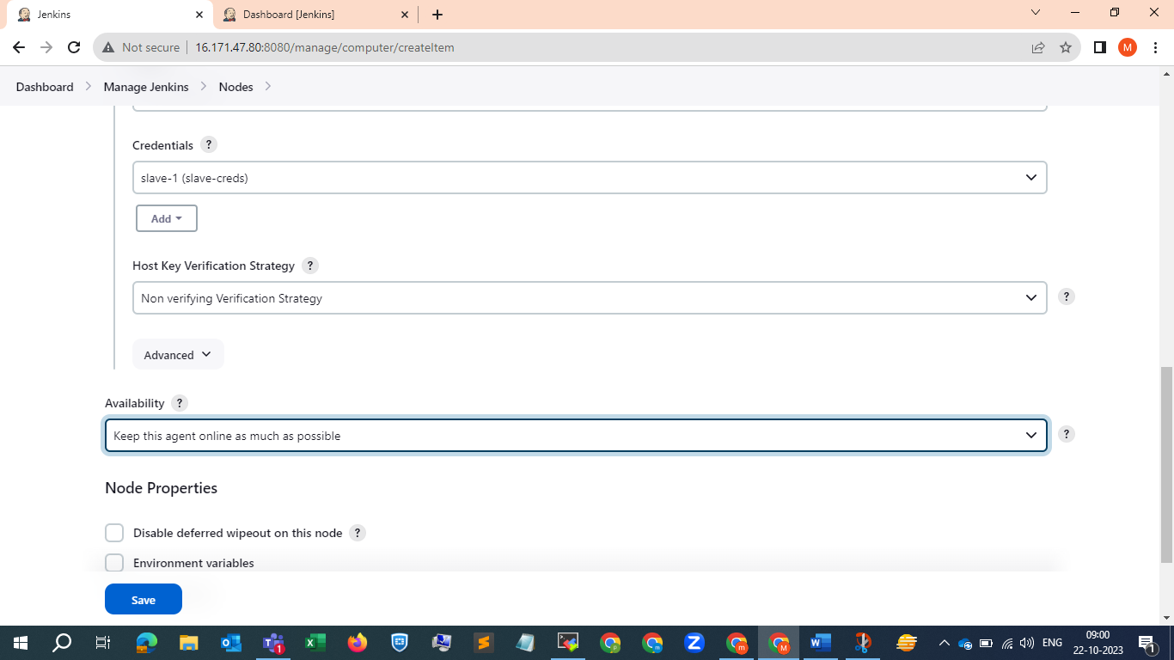

And click on save done, and let’s go to our pipeline script



When we are launching it is showing this error

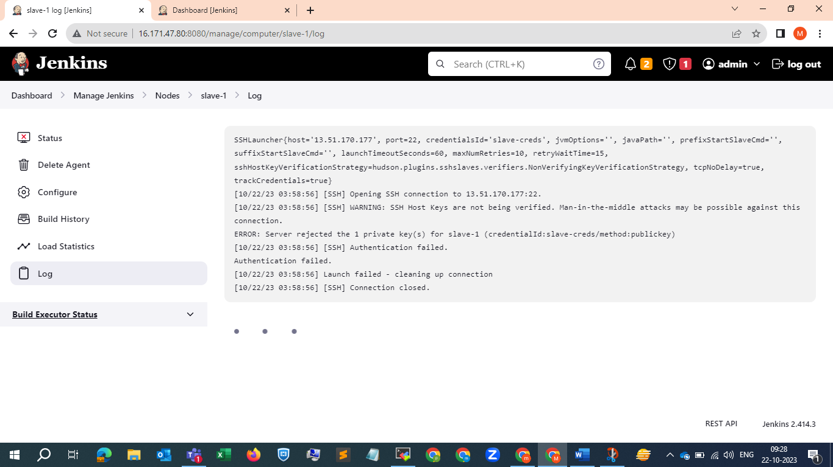

While configuring creds we have given username as slave-1 but we have to give it as root , lets configure that part again and will launch …..

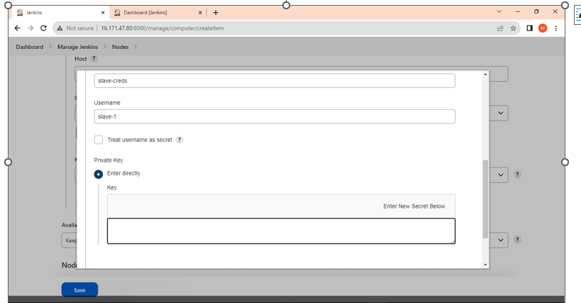

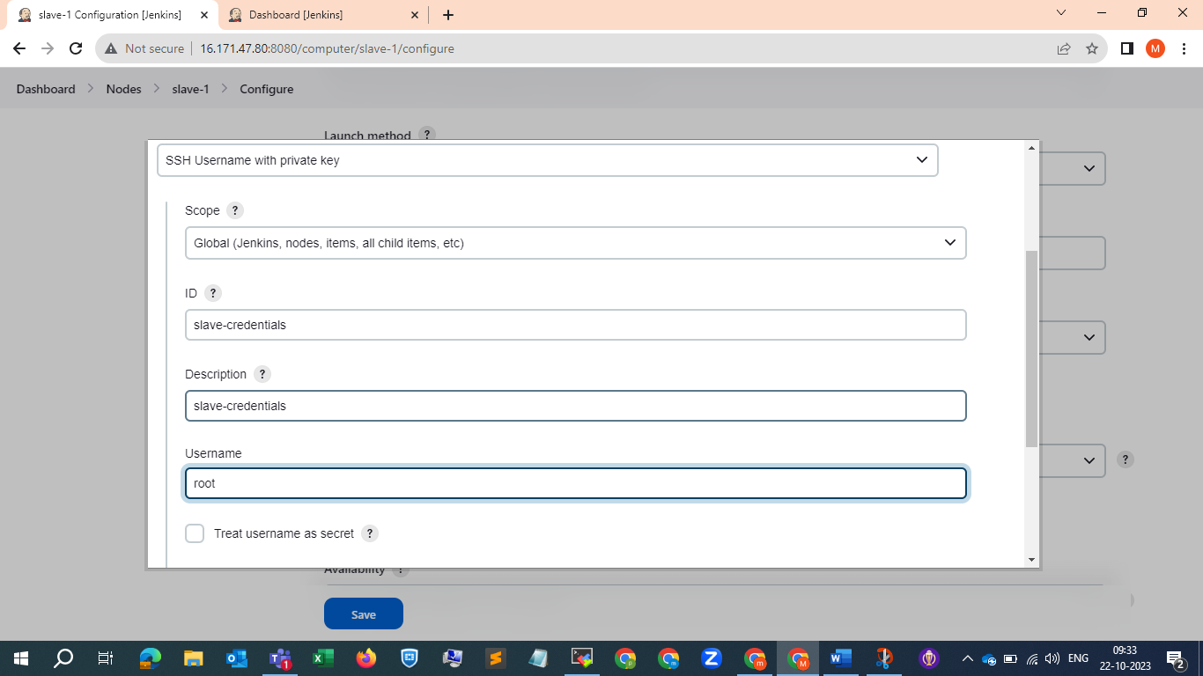

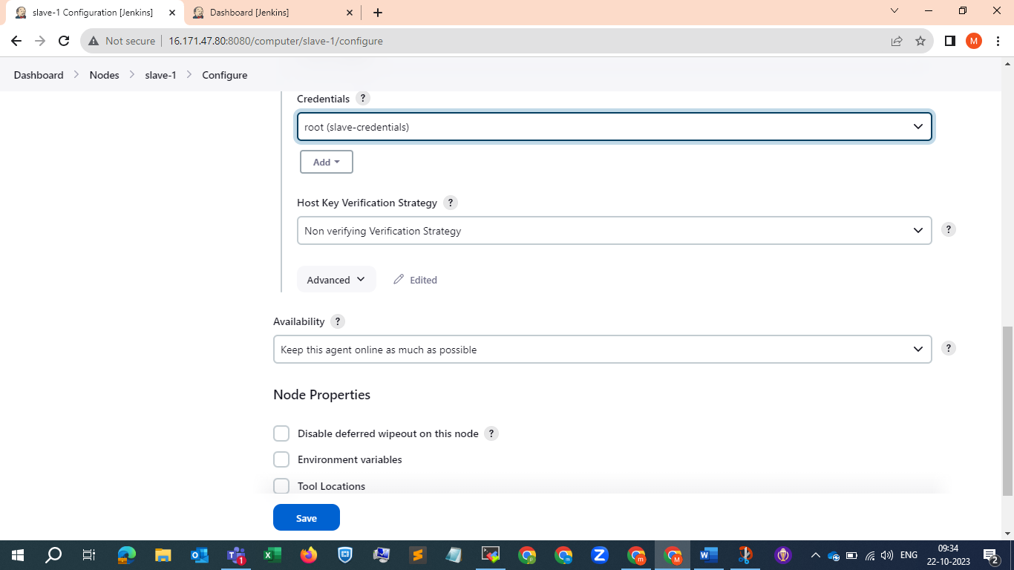

We will save and try it again ….

And it successfully connected

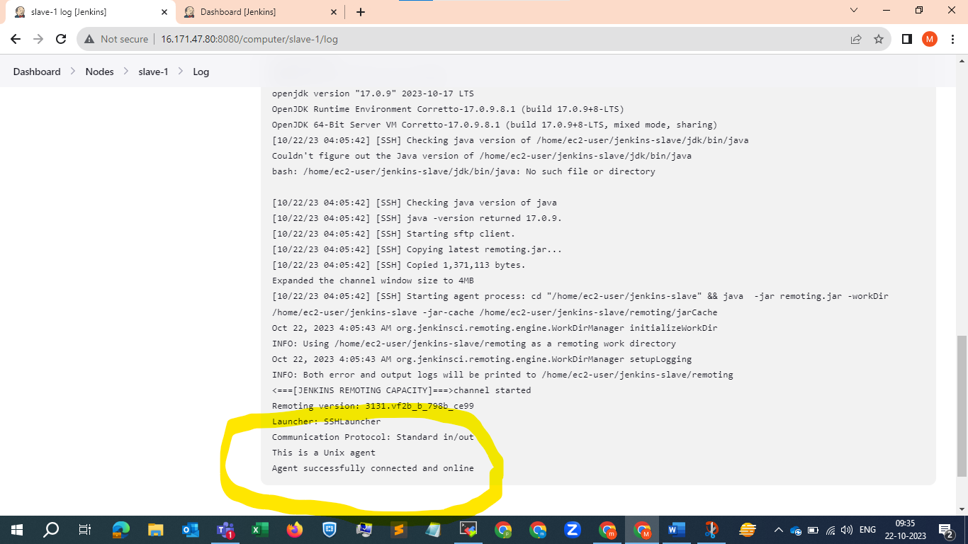

If we observe in our dashboard , it is ready .

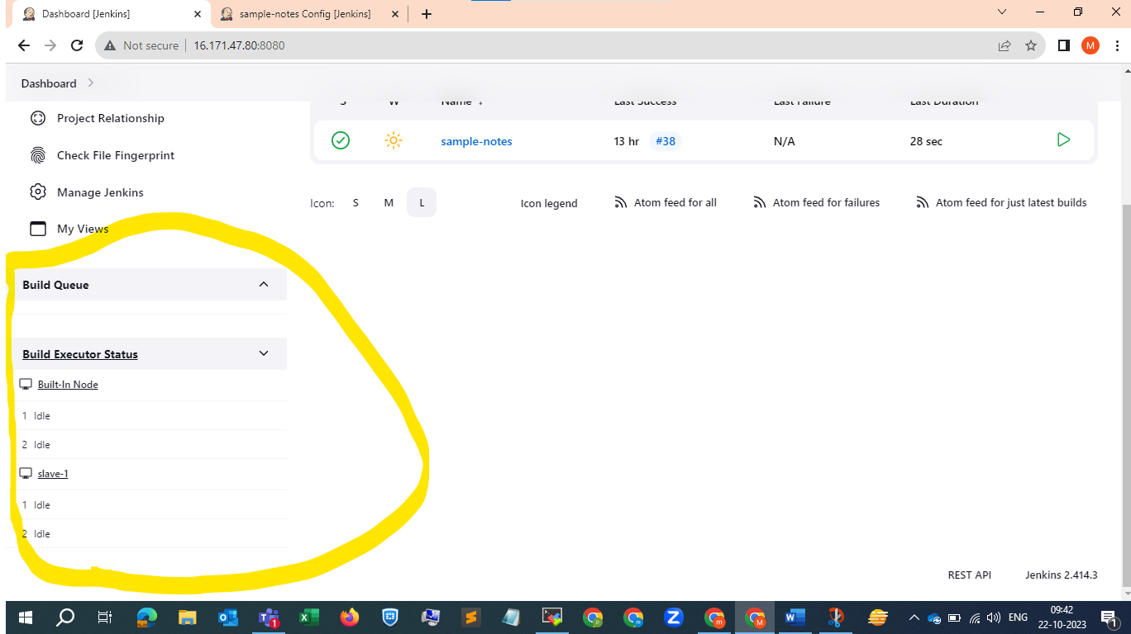

Now we will modify the pipeline script , in place of any we will keep {label ‘slave-1’} as our label name is slave-1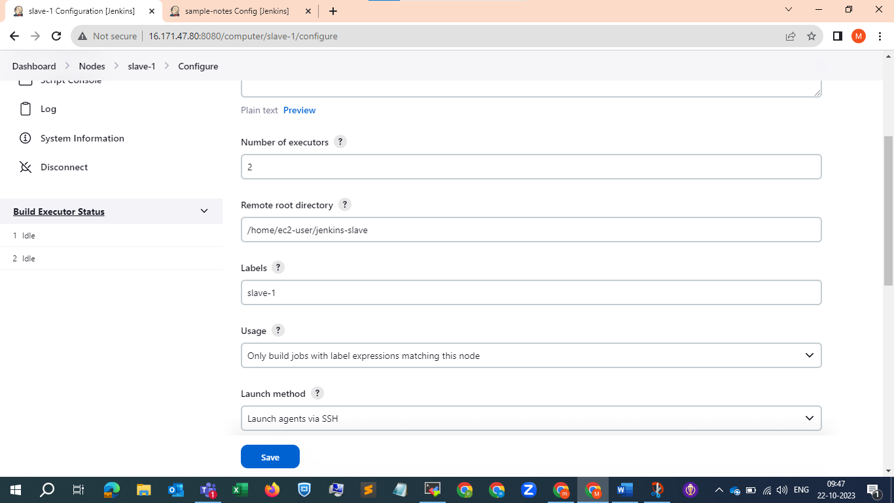

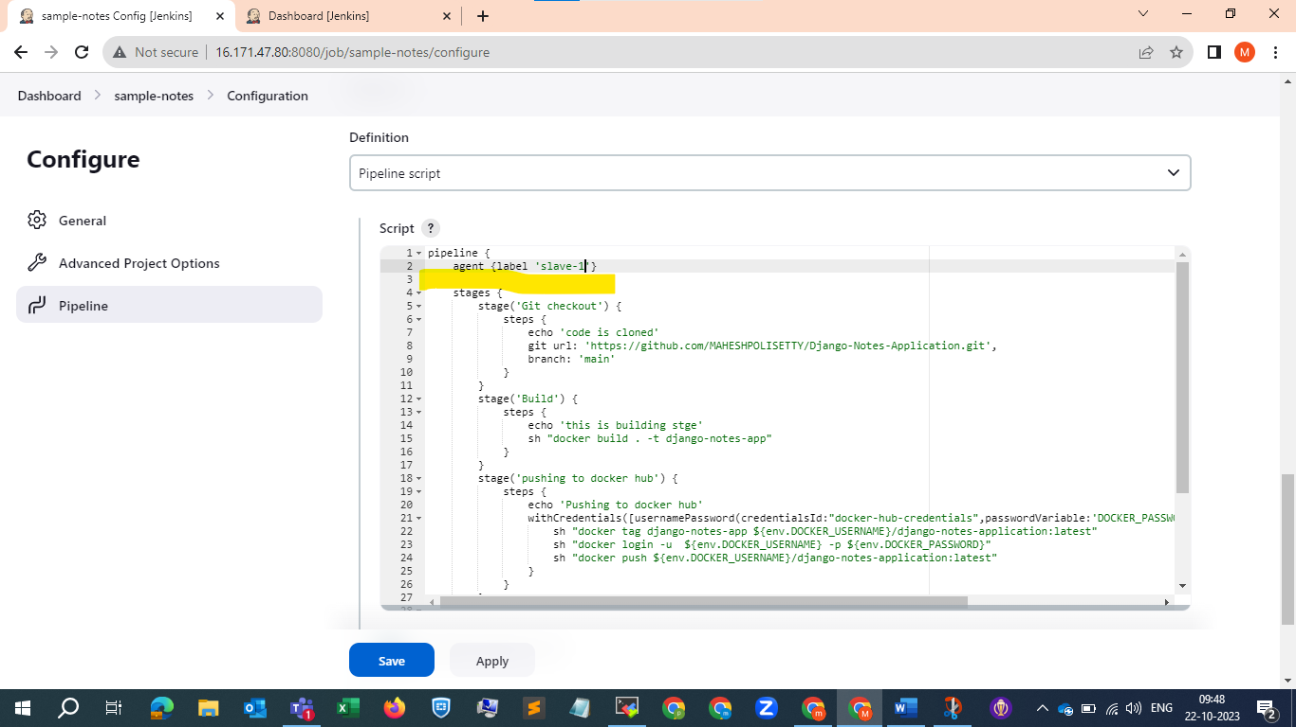

And apply and save , now we will try to build it .

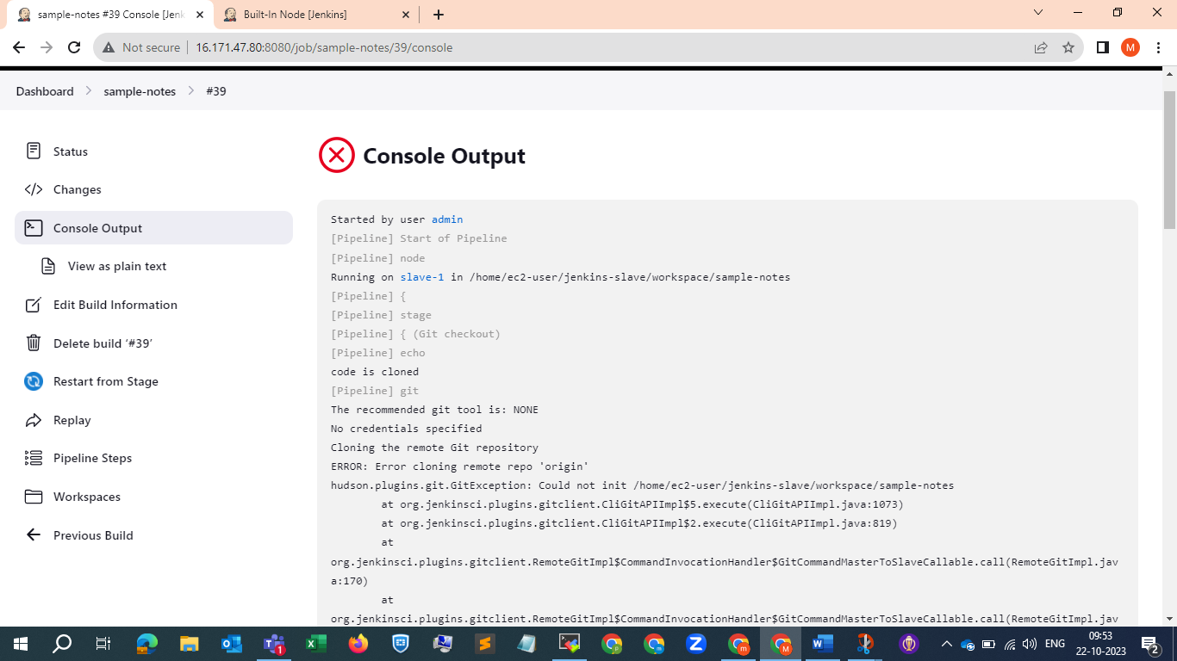

Git error we got , we need to install git it seems ..



Git is installed , now we will try to browse it again .

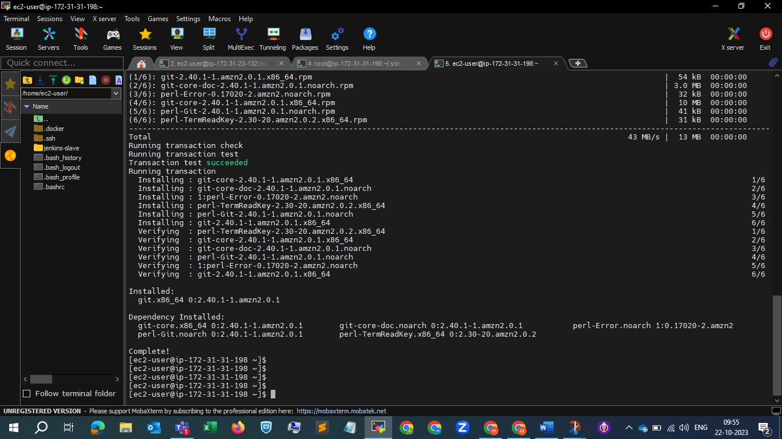

And finally here we go , the build is execute successfully .

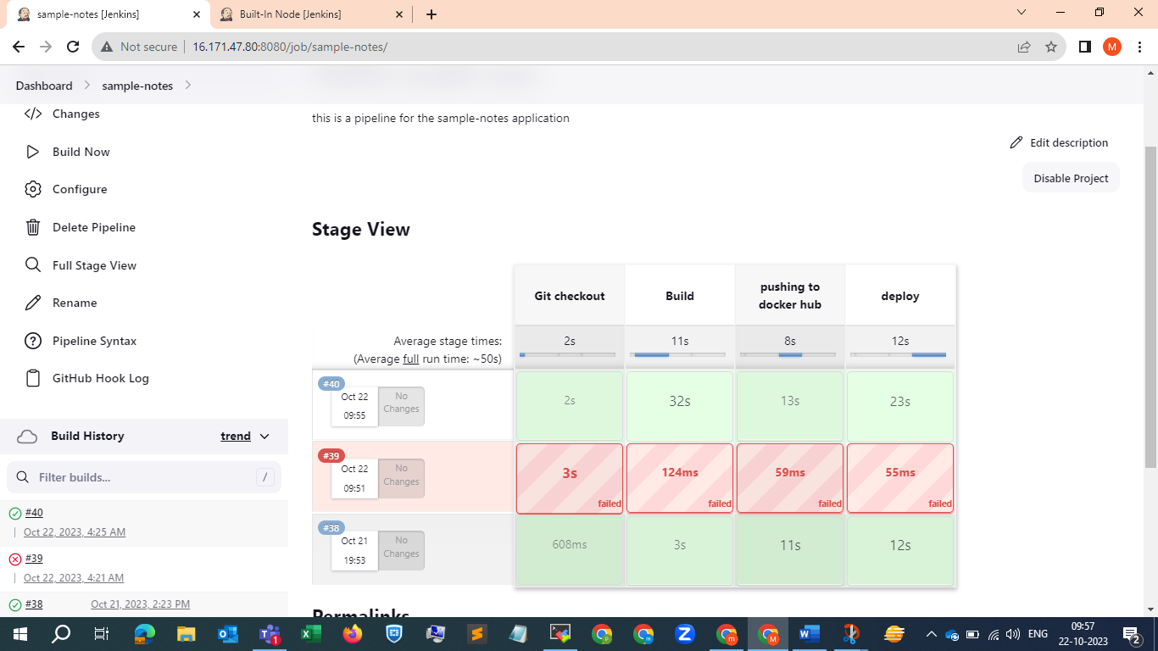

Now we will try to browse that slave ip with the port and check ..

And its successfully done , we are able to access the application in the slave .

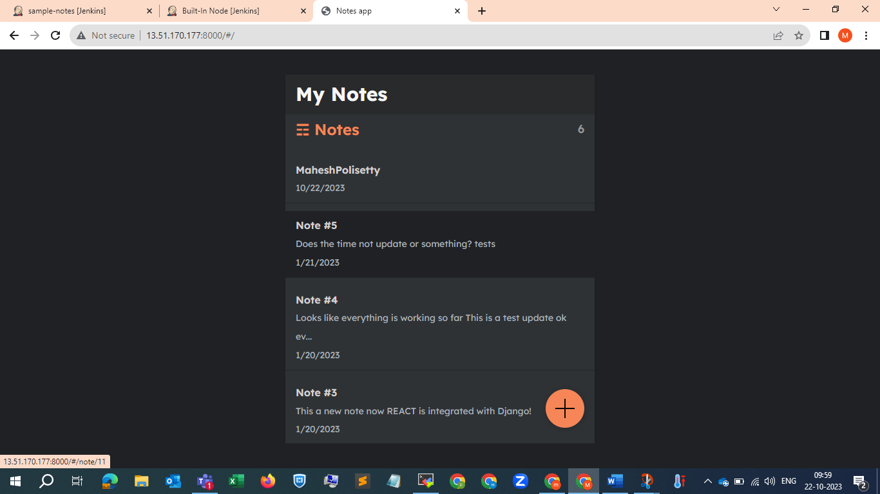

**Conclusion:** The project is completed successfully .